



**Creo Direct Embedded Client Live Integration**

**Installation and Administration Guide**

Table of Contents

**Introduction** 6

**Audience** 6

**Organization** 6

**Server Activities** 6

**Chapter 1** Requirements and Prerequisites 6

Describes the system requirements, software prerequisites, and installation procedures for the CDEC. 6

**Chapter 2** Teamcenter CD4 template installation 6

Describes how to deploy the Teamcenter template for the Creo dataset and home folder related dlls. Also describes how to Add cd4 template to a project in BMIDE and creating of properties in BMIDE 6

**Chapter 3** Creo Preferences 6

Describes how to import Creo_Preferences into Teamcenter and lists out all preferences present in the Creo_Preferences category. 6

**Chapter 4** Workflows 6

Describes the workflows used to generate STP, DXF, PDF, JT files, and configuration of the translators. 6

**Chapter 5** Dispatcher 6

Describes the configurations done in Dispatcher Client, Dispatcher Module, and configuration of the translators in Dispatcher Module. 6

**Chapter 6** PLM/XML Transfer 6

Describes the PLM/XML Transfer mode 6

**Chapter 7** Queries 6

Describes the steps to import queries into Teamcenter 6

**Chapter 8** CDEC License Server Setup 7

Describes the steps to setup CDEC License Server 7

**Chapter 9** AWC configuration 7

Describes the addPartToCreo & openPartInCreo setup in AWC server 7

**Client Activities** 7

**Chapter 10** Creo Direct Embedded Client 7

Describes the CDEC installation steps 7

**Chapter 11** Creo Direct Embedded Client Configuration 7

This chapter describes how to configure Creo Direct Embedded Client(CDEC) 7

**CDEC_Setup_Package** 7

This package will be provided by PLMS, and it contains the following list of folders 7

7

Place the package in a location which doesnot contain folder spaces 7

**Server Activities** 7

**Chapter 1 Requirements and Prerequisites** 8

**About Teamcenter Integration for CDEC** 8

**Creo Elements Embedded Client Requirements and Prerequisites** 8

**System Requirements** 8

**Software Prerequisites** 8

**Teamcenter Active Workspace requirements** 8

**Chapter 2 CD4 template installation** 9

**Installing CD4 template** 9

**Adding CD4 integration template to the BMIDE project** 21

**Creating a Compound Attribute** 33

**Chapter 3 Creo Preferences** 34

**Importing Creo_Preferences** 34

**Importing preferences manually into Teamcenter** 34

**Creo Preferences in Teamcenter** 40

**Creo Preferences for internal use** 40

**CD4_RevisionType_ToParse_InPlmXml** 40

**CD4_Creo_Workflow_SecondaryObjects** 41

**CD4_Bl_IDs_Splitter** 41

**CD4_Bmide_ItemRevision_Class_Type** 42

**CD4_CreoRevision_Qry** 42

**CD4_Creo_RevisionRule** 43

**CD4_Creo_Workflow_Properties** 43

**CD4_Dataset_CreoPackage_Attach_Type** 44

**CD4_Dataset_CreoPackage_DisplayName** 44

**CD4_Dataset_CreoPackage_RealName** 45

**CD4_Dataset_Text** 45

**CD4_Dateset_Text_Relation_Type** 45

**CD4_Elid_Property_DisplayName** 46

**CD4_Elid_Property_RealName** 46

**CD4_Form_Relation_Type** 47

**CD4_Form_Type** 47

**CD4_Form_UniqueId** 48

**CD4_Item_ContentIdHolder_Attr** 48

**CD4_Item_ContentId_Attr** 49

**CD4_MmToTc_Properties** 49

**CD4_SearchFields_LiveIntegration** 51

**CD4_bl_Unique_Attr** 52

**CD4_DsUpload_Configuration** 52

**CD4_ItemRevision_Soa_Type** 53

**CD4_ItemType_ToParse_InPlmXml** 53

**CD4_Property_order** 54

**CD4_CDAT_UniqueAttr** 54

**Creo Preferences for external use** 56

**CD4_User_Default_Folder** 56

**CD4_Allow_Dataset_BulkUpload** 57

**CD4_MI_Creo_Properties** 57

**CD4_MI_Item_Type** 69

**CD4_Enable_Checkin_On_SaveToTC** 70

**CD4_Enable_CreoToPNG** 71

**CD4_ItemCreate_Mandatory_Properties** 72

**CD4_ItemRevision_Release_Type** 73

**CD4_UploadTime** 73

**CD4_BomDetails_Property** 74

**General Category Preferences** 75

**TC_customization_libraries** 75

**Chapter 4 Workflows** 75

**Creo- Generate 2D Neutral Files** 75

**Creo- Generate JT** 76

**Creo- Generate Step** 76

**creotopng** 77

**Workflows Import to Teamcenter** 77

**Importing Workflows manually into Teamcenter** 77

**Chapter 5 Dispatcher** 80

**Teamcenter Dispatcher** 80

**Dispatcher Client Configuration** 80

**Dispatcher Module Configuration** 83

**Translators Configuration** 88

**Creo to JT** 89

**Creo to Neutral** 90

**Creo to PNG** 91

**Creo to STEP** 92

**Chapter 5 PLM/XML Transfer** 94

**Importing Transfer Modes manually into Teamcenter** 94

**Chapter 6 Queries** 96

**Importing Queries** 96

**Importing Queries manually into Teamcenter** 96

**Chapter 7 CDEC License Server Setup** 103

**CDEC License Setup** 103

**Chapter 8 AWC Configuration** 116

**Install addPartToCreo** & **openInCreo** 116

**Client Activities** 121

**Chapter 9 Creo Direct Embedded Client** 121

**Installing Creo Direct Embedded Client(CDEC)** 121

**Chapter 10 How to…?** 121

**Open in Creo Configuration** 121

**Configuration of teamcenter.properties** 122

**Warning:** 126

Document History 127

**Introduction**

This guide describes the prerequisites, installation, administration, and troubleshooting for the Teamcenter Integration for Creo Direct Embedded Client (CDEC).

All the steps in this guide must be performed in the order of the Chapter. Before the installation of the CDEC discussed in Chapter 9, all the steps explained in the before chapters must be performed

**Audience**

The reader of this document should be an experienced Teamcenter system administrator who is familiar with Creo Direct Elements and data management concepts.

**Organization**

**Server Activities**

**Chapter 1** Requirements and Prerequisites

Describes the system requirements, software prerequisites, and installation procedures for the CDEC.

**Chapter 2** Teamcenter CD4 template installation

Describes how to deploy the Teamcenter template for the Creo dataset and home folder-related dlls. Also describes how to Add a CD4 template to a project in BMIDE and creating of properties in BMIDE

**Chapter 3** Creo Preferences

Describes how to import Creo_Preferences into Teamcenter and lists out all preferences present in the Creo_Preferences category.

**Chapter 4** Workflows

Describes the workflows used to generate STP, DXF, PDF, JT files, and configuration of the translators.

**Chapter 5** Dispatcher

Describes the configurations done in Dispatcher Client, Dispatcher Module, and configuration of the translators in Dispatcher Module.

**Chapter 6** PLM/XML Transfer

Describes the PLM/XML Transfer mode

**Chapter 7** Queries

Describes the steps to import queries into Teamcenter

**Chapter 8** CDEC License Server Setup

Describes the steps to setup CDEC License Server

**Chapter 9** AWC configuration

Describes the addPartToCreo & openPartInCreo setup in AWC server

**Client Activities**

**Chapter 10** Creo Direct Embedded Client

Describes the CDEC installation steps

**Chapter 11** Creo Direct Embedded Client Configuration

This chapter describes how to configure Creo Direct Embedded Client(CDEC)

**CDEC_Setup_Package**

***Important Note: Please remember that the folder structure of CDEC_ Setup_Package (including all the subfolders and files) should not be changed, and it should be retained as it is***

This package will be provided by PLMS, and it contains the following list of folders

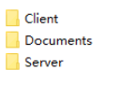

Place the package in a location that does not contain folder spaces

This CDEC_ Setup_Package is used to set up the CDEC environment in the following chapters

Each chapter here explains the setup of the CDEC environment using the installable listed above

**Server Activities**

For Performing Server activities user must use the **Server** folder in the **CDEC_ Setup_Package**

The server folder contains the following list of folders that are used for the server-side configuration

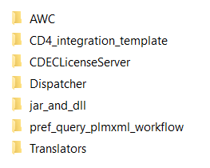

**Chapter 1 Requirements and Prerequisites**

This chapter describes the system requirements and prerequisites for installing the CDEC.

**About Teamcenter Integration for CDEC**

The integration ensures CED data is managed in TeamCenter as your company's single source of truth, eliminating duplicates, along with document -, BOM -, and process management, which enables designers to concentrate on design tasks rather than administration.

**Creo Elements Embedded Client Requirements and Prerequisites**

This section describes the system requirements and software prerequisites for installing the CDEC.

**System Requirements**

The CDEC supports the minimum system recommendations for operating a Windows-based Teamcenter server (Windows Server 2008, Windows Server 2012, and Windows Server 2016).

CDEC will be supported for Windows 10 operating system.

.NET version must be a minimum of 4.5

**Software Prerequisites**

CDEC v5.3 supports the following versions of Teamcenter software products.

- Teamcenter 11.x or above

*Note: CDEC uses Teamcenter in a four-tier mode in client hence Teamcenter must be installed in four-tier.*

The minimum version of Creo Direct Elements must be 18.0

Based on the customer’s request the version earlier than 18.0 of Creo can also be supported.

**Teamcenter Active Workspace requirements**

Chrome/Edge/Firefox browser must be installed for Active Workspace

The minimum version of supported Teamcenter Active Workspace is 5.1

Integration with Teamcenter Active Workspace must be properly activated and configured.

**Chapter 2 CD4 template installation**

This chapter describes how to deploy the Teamcenter template for the Creo dataset and home folder-related dlls. Also describes how to Add a CD4 template to a project in BMIDE and creating of properties in BMIDE

**Installing CD4 template**

The instructions in this section apply if Creo integration (CD4 template) has **never** been installed in the target Teamcenter environment.

Copy the CD4 template from the **CDEC_ Setup_Package** provided by PLMS to a local folder on the Teamcenter server machine. From now on, this folder will be referred to as **<CD4_integration_template>**.

Launch **Teamcenter Environment Manager** (TEM) and perform the following steps.

1. Select **Configuration Manager** and click **Next**.

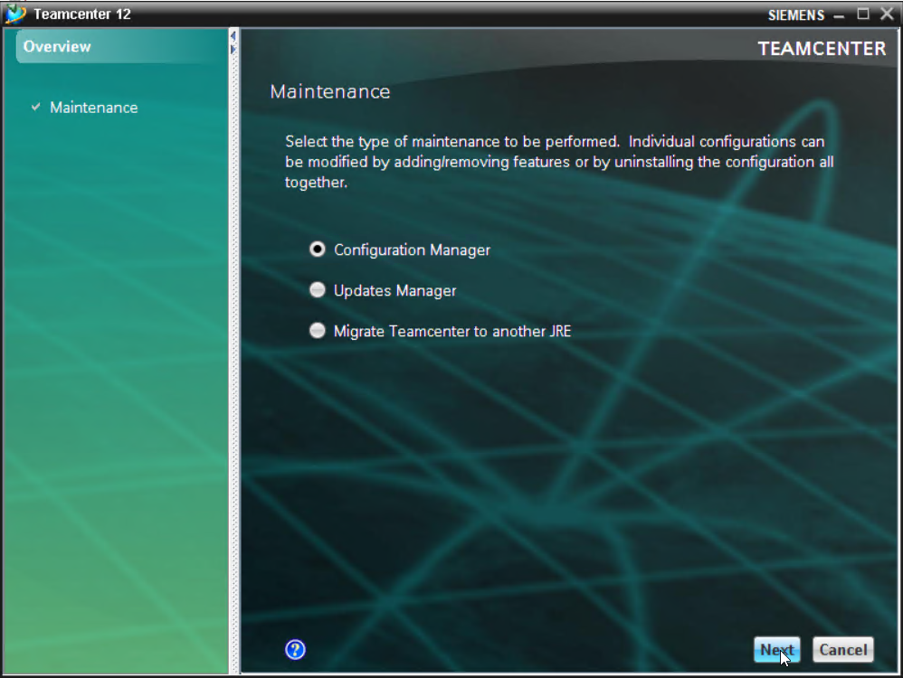

1. Select **Perform maintenance on an existing configuration** and click **Next**.

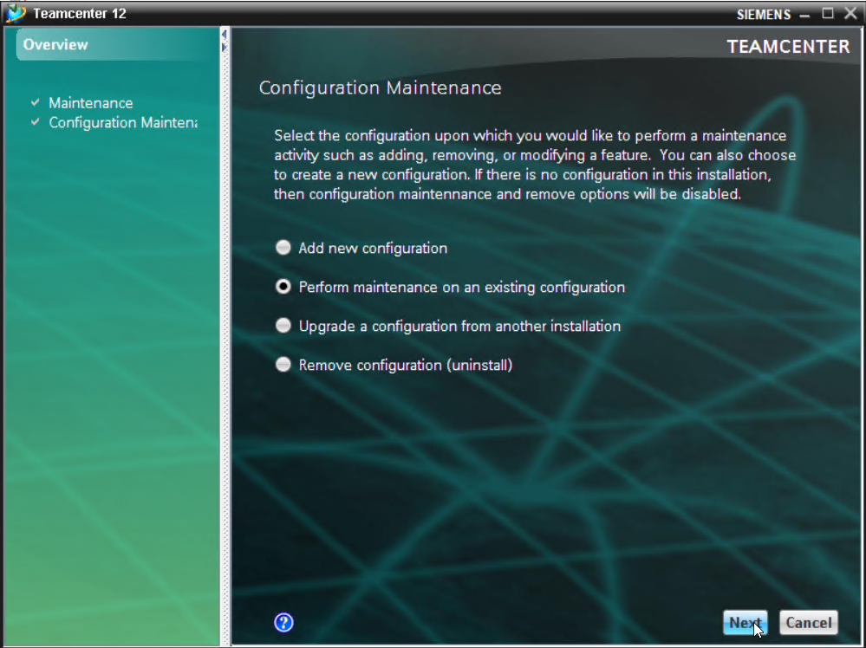

1. Select the existing configuration and click **Next**.

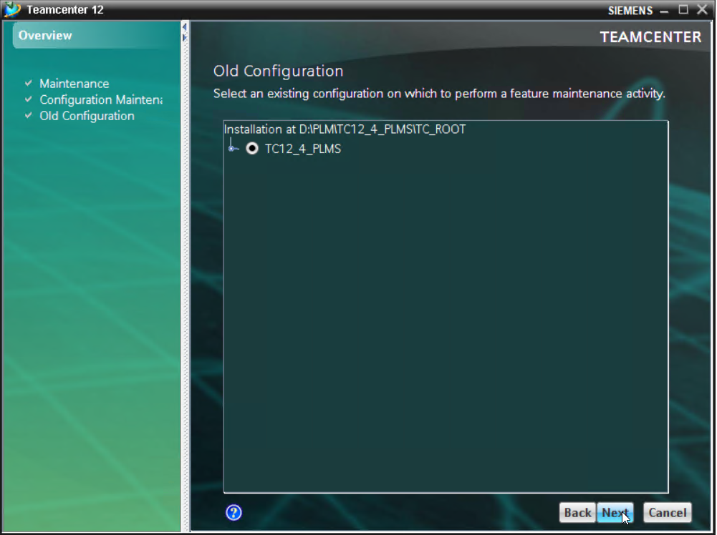

1. For the first time installation of the template select **Add/Remove Features**

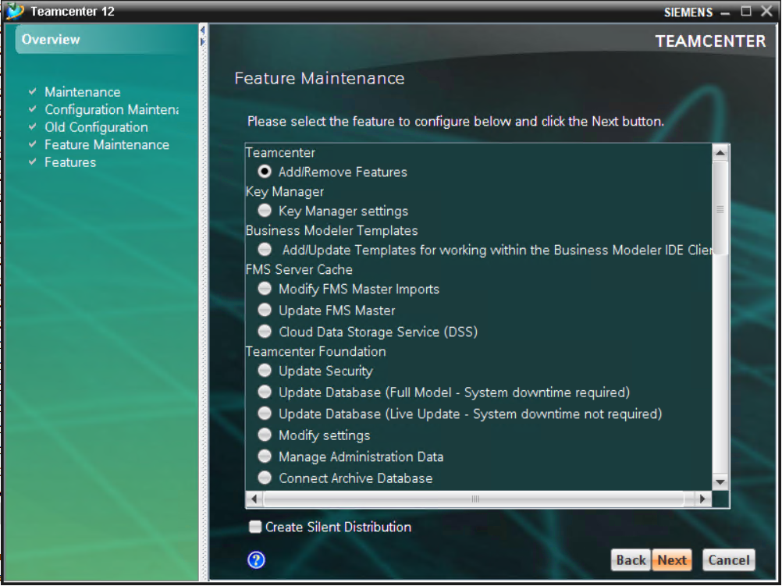

1. Click the **Browse** button to locate **<CD4_integration_template>**.

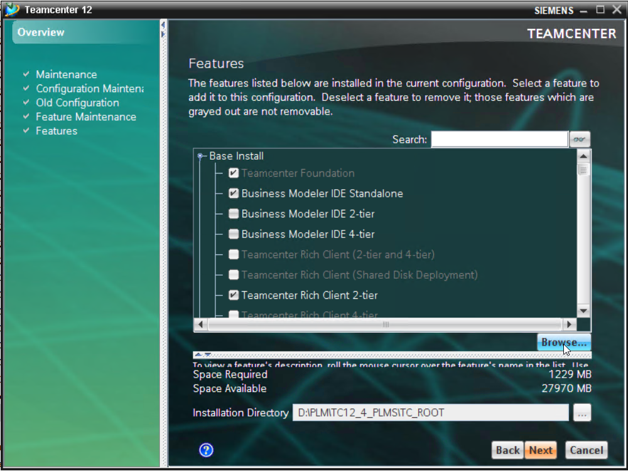

1. Select the **feature_cd4integration.xml** in the **tem_contributions** folder of the **<CD4_integration_template>**.

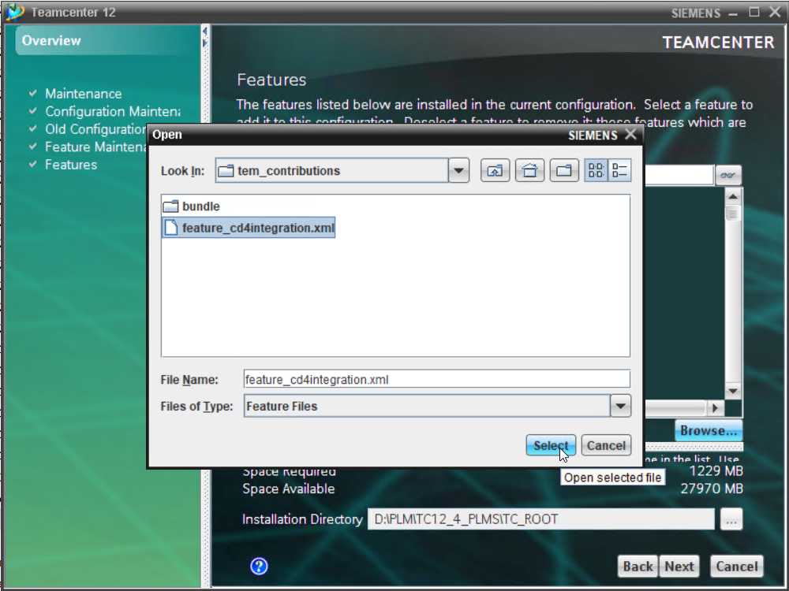

1. Verify that the **CD4Integration** feature is selected and click **Next**.

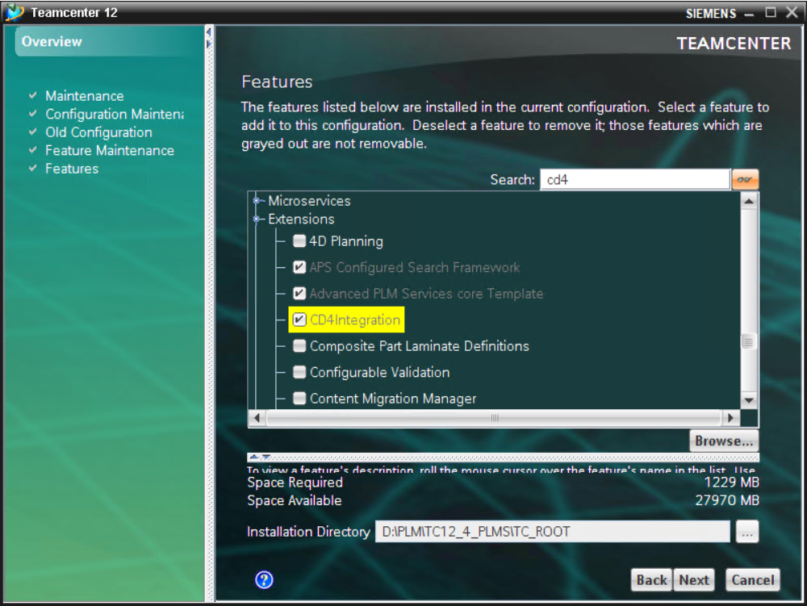

1. Enter Teamcenter Administrative User/Password and click **Next**.

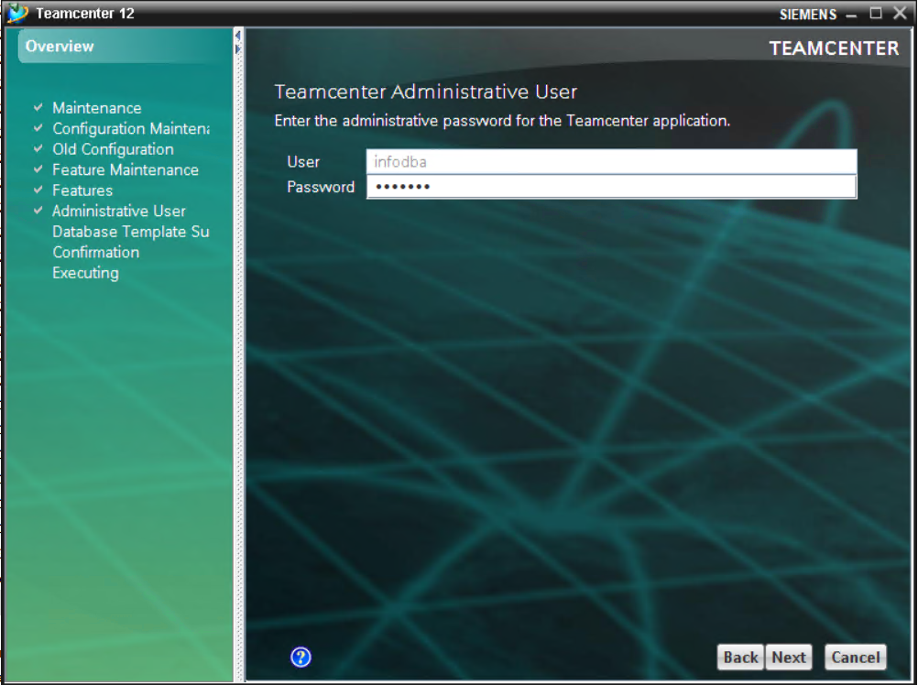

1. Database Template Summary will be shown

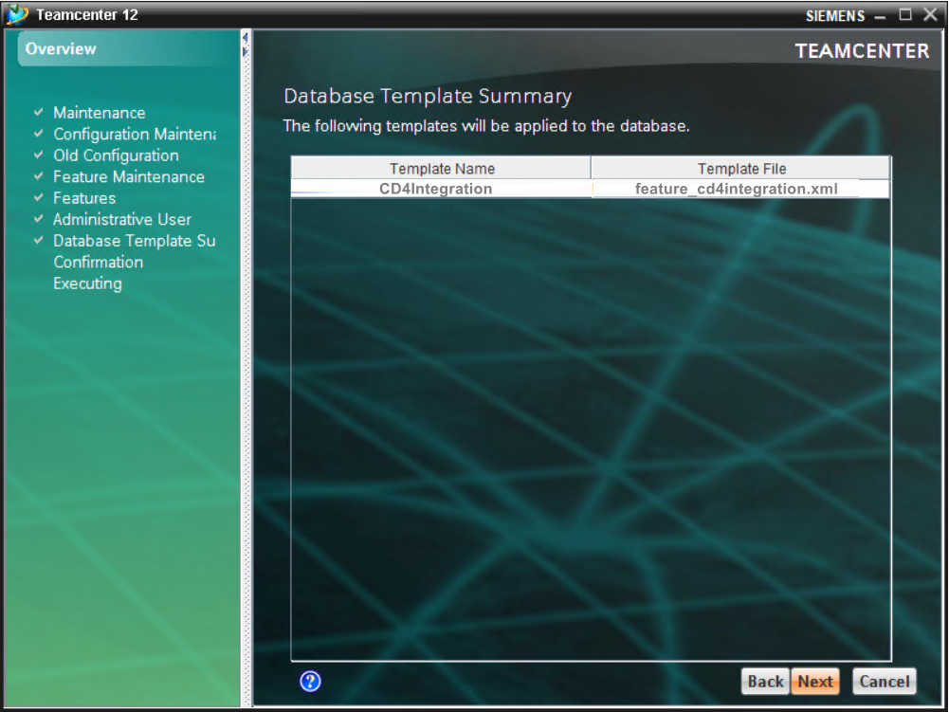

1. To start the installation of **<CD4_integration_template>**, click **Start.**

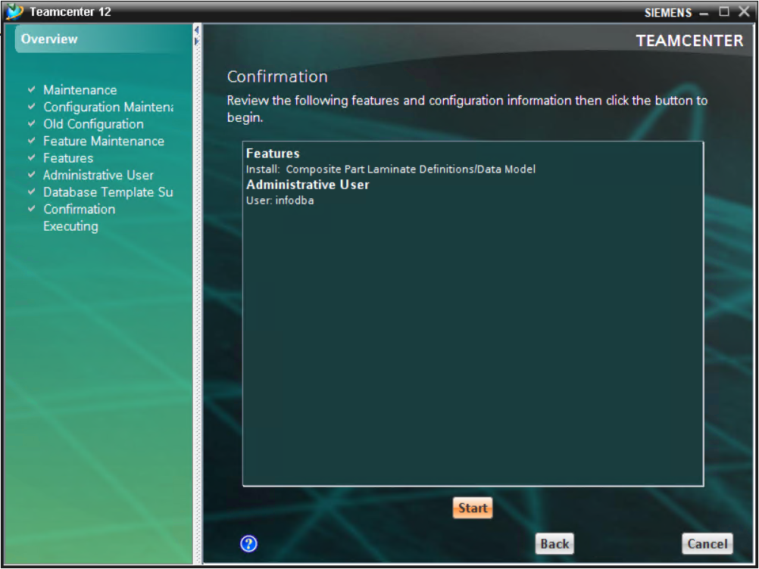

1. When the **Successful Window** appears, **Close** the Install Features Panel.

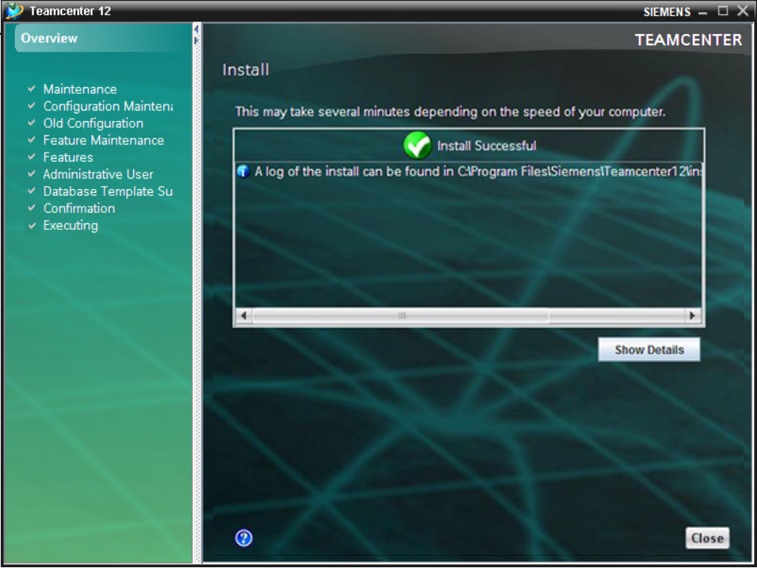

**Adding CD4 integration template to the BMIDE project**

Adding the CD4 integration template to the foundation package in the BMIDE using TEM deployment

Launch **Teamcenter Environment Manager** (TEM) and perform the following steps.

1. Select **Configuration Manager** and click **Next**.



1. Select **Perform maintenance on an existing configuration** and click **Next**.



1. Select the existing configuration and click **Next**.



1. Select Add/**Update Templates for working within the Business Modeler IDE Client FMS Server Cache** and click **Next.**

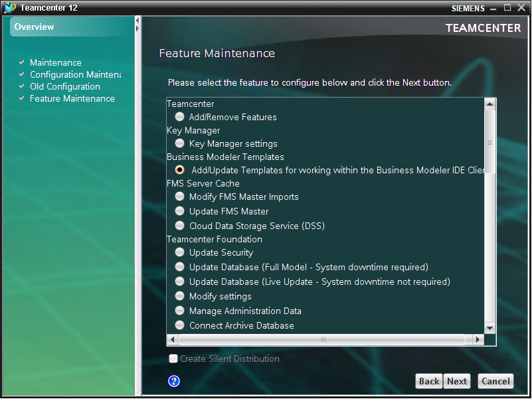

1. Click **Add** to Browse the CD4 integration template

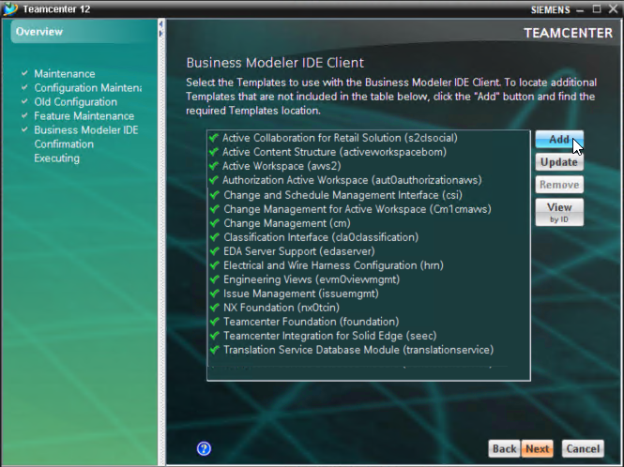

1. Browse the CD4 integration template location and select the **feature_cd4integration.xml** inside the tem_contributions folder of the CD4 integration template folder and click **Open**

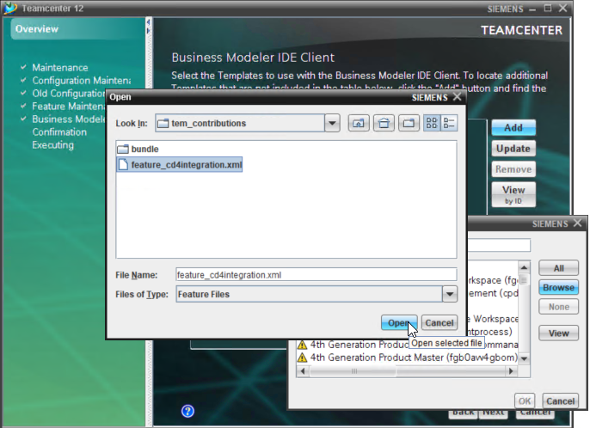

1. To load the template, Select the CD4Integration and click OK

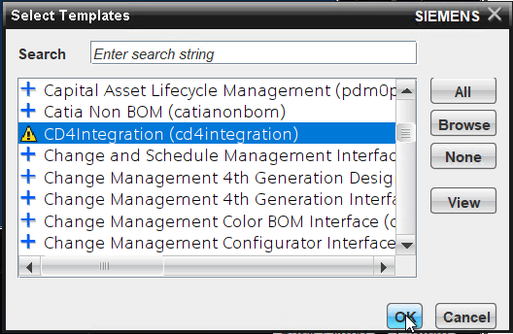

1. Once the template is added then it will appear in the list and click **Next**

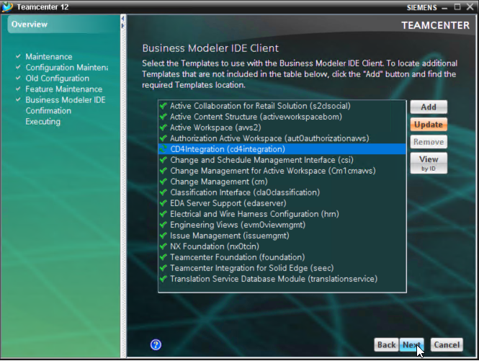

1. To start the installation of **<CD4_integration_template>** to the foundation package, click **Start.**

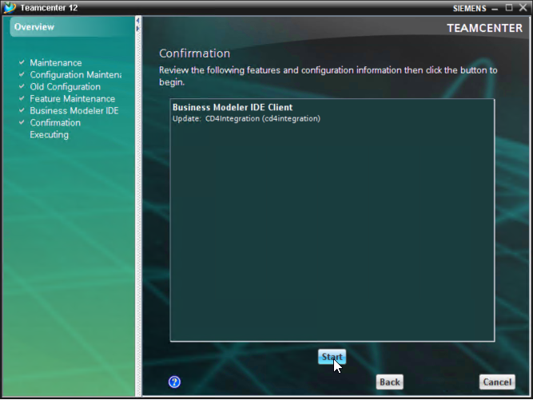

1. When the **Successful Window** appears, **Close** the Install Features Panel.

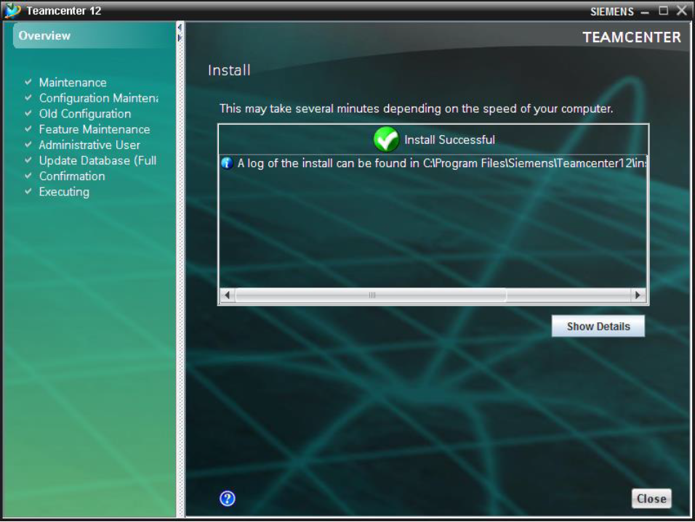

After the successful deployment Open BMIDE and go to the Foundation Project folder -> right-click -> select **Properties**

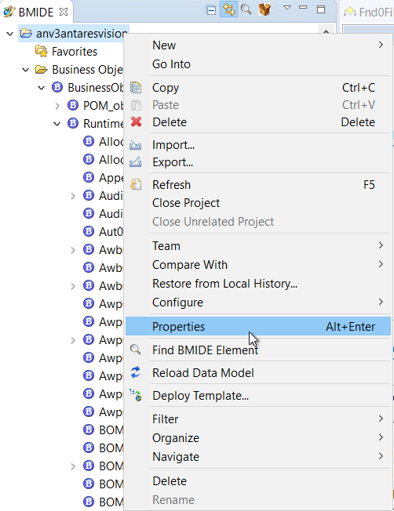

Expand Teamcenter and select BMIDE

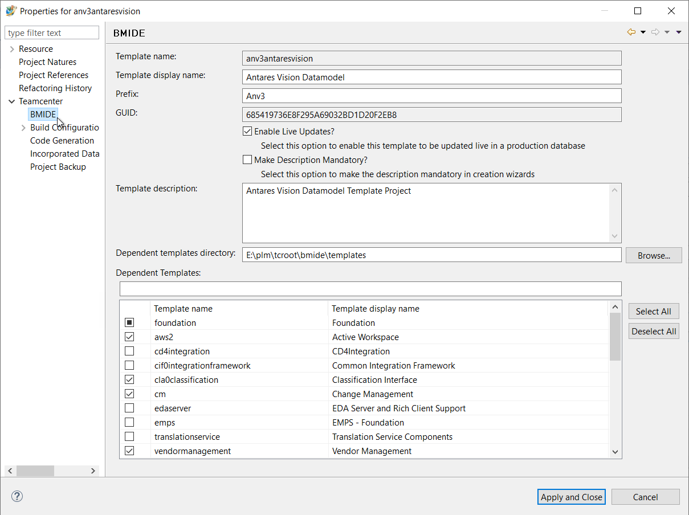

In the Dependent Templates enable the **cd4integration** and click **Apply and Close**

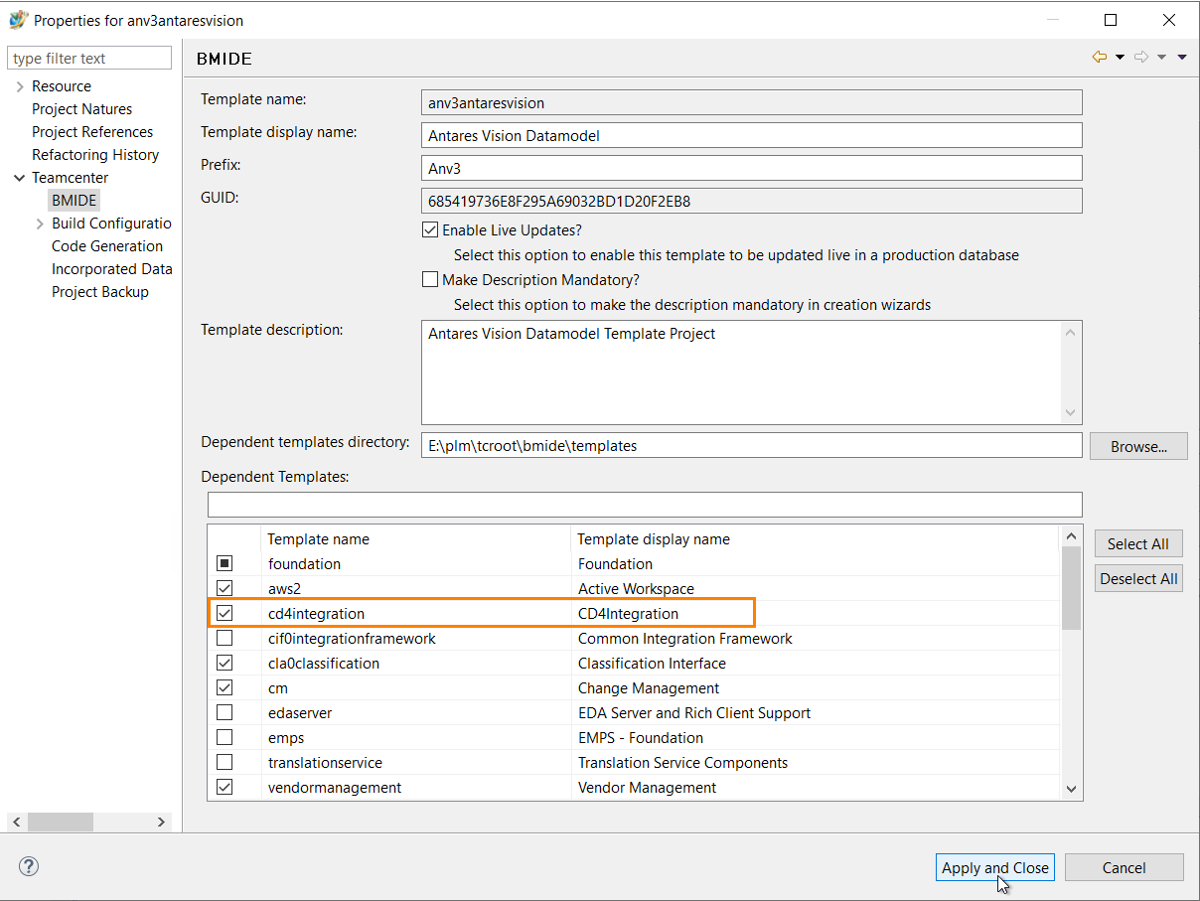

**Creating a Compound Attribute**

Create a compound attribute in BMIDE as shown in the below image for all item types that will be used in CDEC. Here in the below image, d9 is used as a prefix but this can be used according to your data model

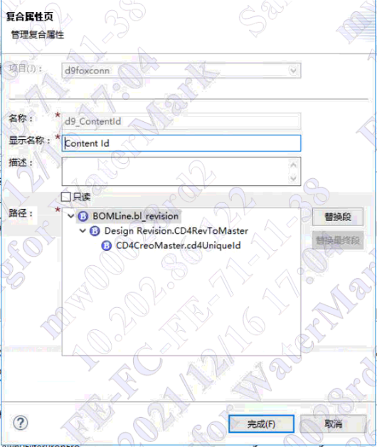

After creating the Content Id and Elid attributes, do a **TEM** deployment of the foundation package

**Chapter 3 Creo Preferences**

This chapter provides information about Creo Preferences and how to import the preference into Teamcenter.

**Importing Creo_Preferences**

***Important Note: Please remember that the folder structure of CDEC_ Setup_Package (including all the subfolders and files) should not be changed, and it should be retained as it is***

**Importing preferences manually into Teamcenter**

1. Open Teamcenter.
2. In the “My Teamcenter” session go to **Edit à Options…**

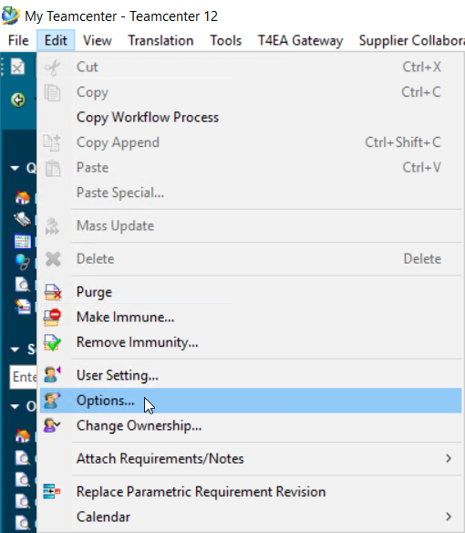

1. In the Options dialog, click the **Search** tab

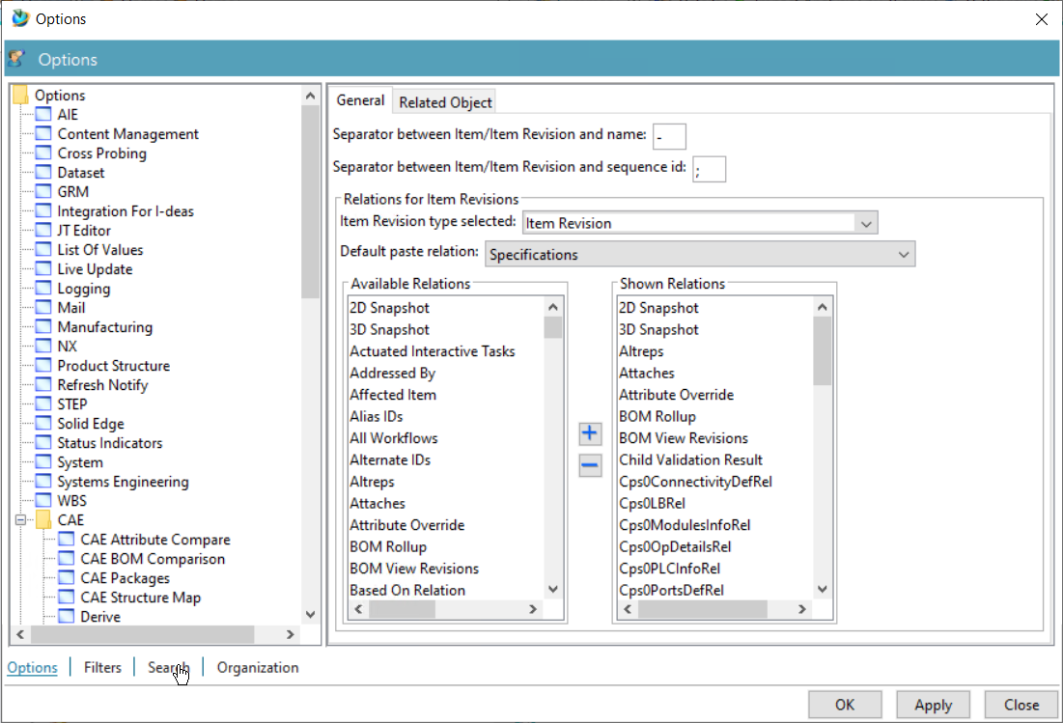

1. Go to the **Import** tab

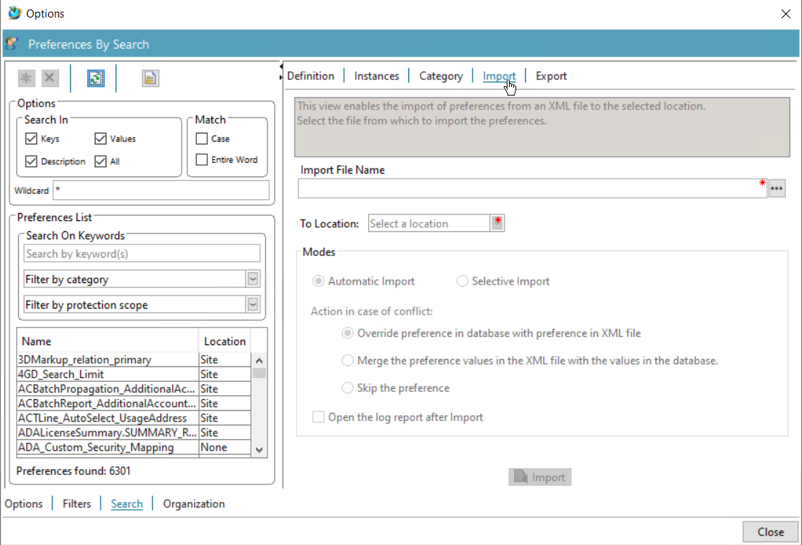

1. In the Import File Name, use this “**…**” button to select the source XML file.

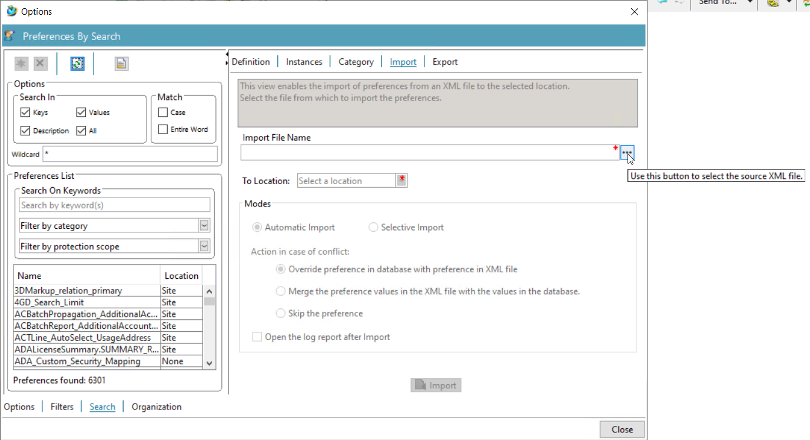

1. The import dialog will appear, select the Preference XML file from the “***CDEC_Setup_Package\Server\pref_query_plmxml_workflow\InputFiles***”Preferences and click **Import**

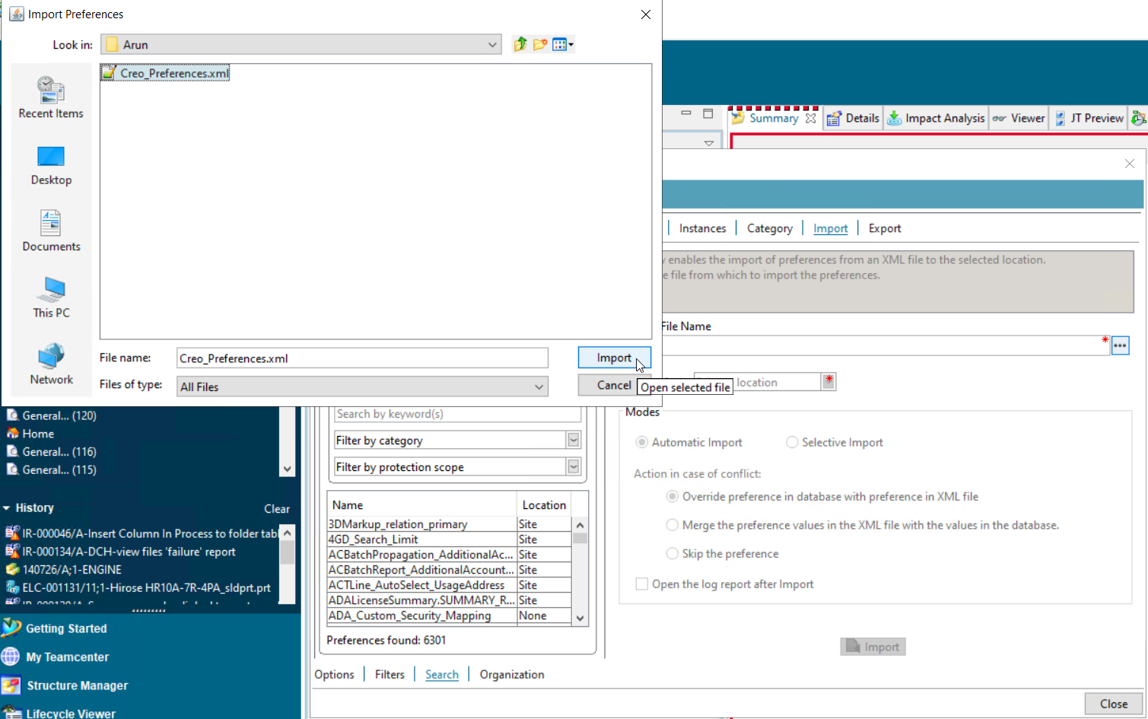

1. Select the location as **Site**.

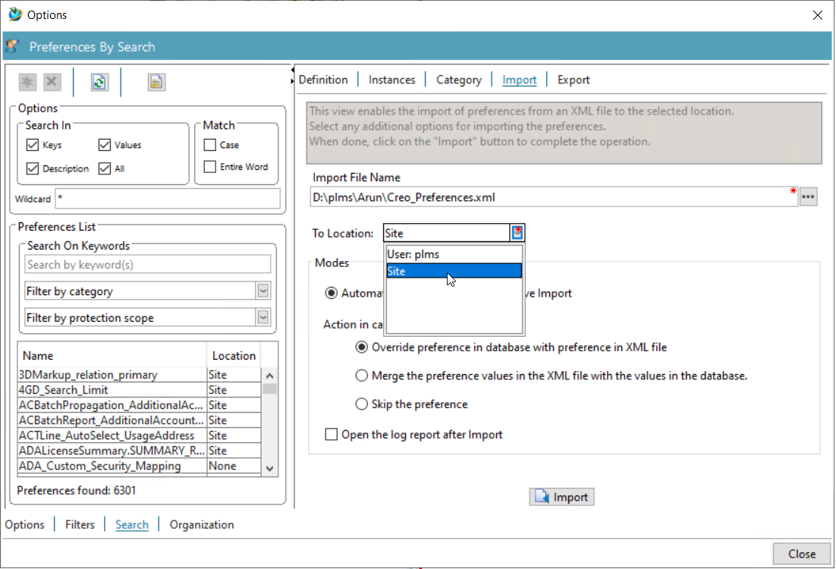

1. Select the **Automatic Import** Mode and also select the **override option** during the action in case of conflict.

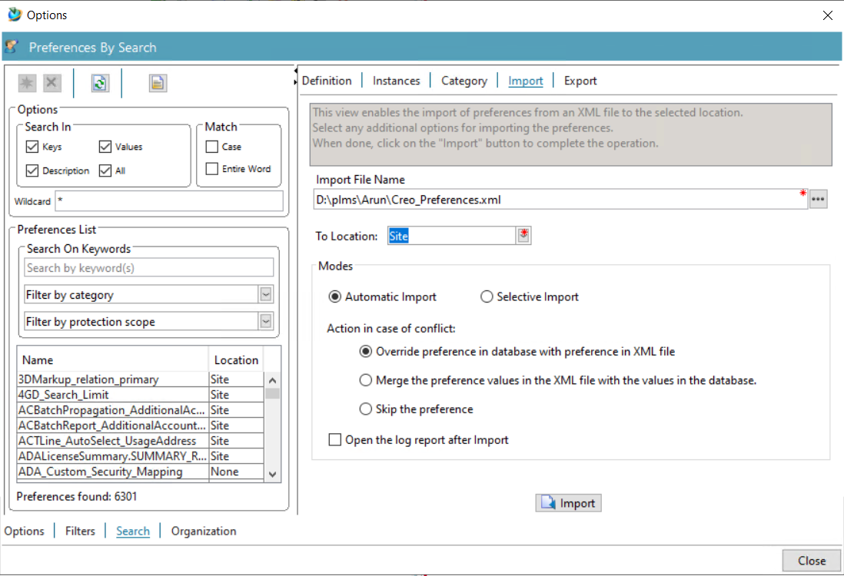

1. Click **Import** to import the Creo_Preferences to Teamcenter.

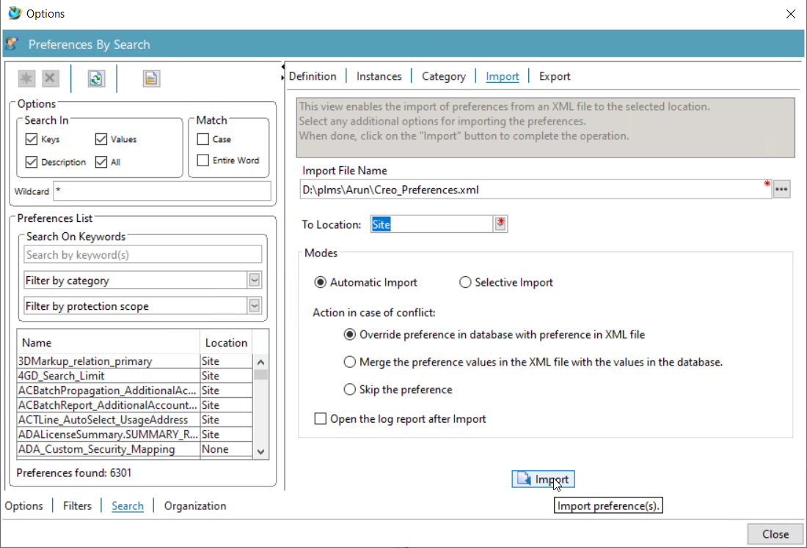

**Creo Preferences in Teamcenter**

The following are the Creo and Teamcenter integration Preferences which get added under the category **Creo_Preferences** after the import of the “Creo_Preferences.xml”

**Creo Preferences for internal use**

**CD4_RevisionType_ToParse_InPlmXml**

**DESCRIPTION**

Parse and find value in plmxml file. For internal use only

**VALID**

**VALUES**

DesignRevision

**DEFAULT**

**VALUE**

DesignRevision

**DEFAULT**

**PROTECTION**

**SCOPE**

Site

**CD4_Creo_Workflow_SecondaryObjects**

**DESCRIPTION**

Secondary object to show in creo workflow UI. For internal use only

**VALID**

**VALUES**

IMAN_specification

**DEFAULT**

**VALUE**

IMAN_specification

**DEFAULT**

**PROTECTION**

**SCOPE**

Site

**CD4_Bl_IDs_Splitter**

**DESCRIPTION**

Bom child splitter. For internal use only

**VALID**

**VALUES**

;

**DEFAULT**

**VALUE**

;

**DEFAULT**

**PROTECTION**

**SCOPE**

Site

**CD4_Bmide_ItemRevision_Class_Type**

**DESCRIPTION**

Migration preference - using in perform action. For internal use only

**VALID**

**VALUES**

Teamcenter.Soa.Client.Model.Strong.D9_MEDesignRevision

**DEFAULT**

**VALUE**

Teamcenter.Soa.Client.Model.Strong.D9_MEDesignRevision

**DEFAULT**

**PROTECTION**

**SCOPE**

Site

**CD4_CreoRevision_Qry**

**DESCRIPTION**

Creo item revision query. For internal use only

**VALID**

**VALUES**

CreoRevisions_MultiItem...

**DEFAULT**

**VALUE**

CreoRevisions_MultiItem...

**DEFAULT**

**PROTECTION**

**SCOPE**

Site

**CD4_Creo_RevisionRule**

**DESCRIPTION**

The value of this preference is automatically updated for the protection scope ‘User’ when the revision rule is changed in the User Settings of CDEC. To see the value in Teamcenter the user must be use exact login credentails in which he changed the value of Revision Rule in CDEC user settings. For internal use only

**VALID**

**VALUES**

Any Revision rule present in Teamcenter

**DEFAULT**

**VALUE**

Latest Working

**DEFAULT**

**PROTECTION**

**SCOPE**

User

**CD4_Creo_Workflow_Properties**

**DESCRIPTION**

Properties to show in Assign workflow UI in CDEC. For internal use only

**VALID**

**VALUES**

object_desc

owning_group

**DEFAULT**

**VALUE**

object_desc

owning_group

**DEFAULT**

**PROTECTION**

**SCOPE**

Site

**CD4_Dataset_CreoPackage_Attach_Type**

**DESCRIPTION**

Creo package dataset attachment type. For internal use only

**VALID**

**VALUES**

IMAN_specification

**DEFAULT**

**VALUE**

IMAN_specification

**DEFAULT**

**PROTECTION**

**SCOPE**

Site

**CD4_Dataset_CreoPackage_DisplayName**

**DESCRIPTION**

This preference is needed for the CDEC to know in which display name of dataset type has to be used for uploading the Creo files in the Teamcenter. For internal use only

**VALID**

**VALUES**

Creo Package

**DEFAULT**

**VALUE**

Creo Package

**DEFAULT**

**PROTECTION**

**SCOPE**

Site

**CD4_Dataset_CreoPackage_RealName**

**DESCRIPTION**

This preference is needed for the CDEC to know in which real name of dataset type has to be used for uploading the Creo files in the Teamcenter. For internal use only

**VALID**

**VALUES**

CD4CreoPackage

**DEFAULT**

**VALUE**

CD4CreoPackage

**DEFAULT**

**PROTECTION**

**SCOPE**

Site

**CD4_Dataset_Text**

**DESCRIPTION**

Text dataset type. For internal use only

**VALID**

**VALUES**

Text

**DEFAULT**

**VALUE**

Text

**DEFAULT**

**PROTECTION**

**SCOPE**

Site

**CD4_Dateset_Text_Relation_Type**

**DESCRIPTION**

Text dataset relation type. For internal use only

**VALID**

**VALUES**

CD4CreoProps

**DEFAULT**

**VALUE**

CD4CreoProps

**DEFAULT**

**PROTECTION**

**SCOPE**

Site

**CD4_Elid_Property_DisplayName**

**DESCRIPTION**

This preference is used to show the display name of the ELID property and this is for migration purpose only. For internal use only

**VALID**

**VALUES**

Elid

**DEFAULT**

**VALUE**

Elid

**DEFAULT**

**PROTECTION**

**SCOPE**

Site

**CD4_Elid_Property_RealName**

**DESCRIPTION**

This property mapping to Creo ELID for migration purpose. For internal use only

**VALID**

**VALUES**

plm5_Elid

**DEFAULT**

**VALUE**

plm5_Elid

**DEFAULT**

**PROTECTION**

**SCOPE**

Site

**CD4_Form_Relation_Type**

**DESCRIPTION**

Form relation type. For internal use only

**VALID**

**VALUES**

CD4RevToMaster

**DEFAULT**

**VALUE**

CD4RevToMaster

**DEFAULT**

**PROTECTION**

**SCOPE**

Site

**CD4_Form_Type**

**DESCRIPTION**

Creo master form type. For internal use only

**VALID**

**VALUES**

CD4CreoMaster

**DEFAULT**

**VALUE**

CD4CreoMaster

**DEFAULT**

**PROTECTION**

**SCOPE**

Site

**CD4_Form_UniqueId**

**DESCRIPTION**

Creo Content id stored in form under this attribute. For internal use only

**VALID**

**VALUES**

cd4UniqueId

**DEFAULT**

**VALUE**

cd4UniqueId

**DEFAULT**

**PROTECTION**

**SCOPE**

Site

**CD4_Item_ContentIdHolder_Attr**

**DESCRIPTION**

Creo content id holder attribute in Item revision. For internal use only

**VALID**

**VALUES**

cd4InstanceIdCp

**DEFAULT**

**VALUE**

cd4InstanceIdCp

**DEFAULT**

**PROTECTION**

**SCOPE**

Site

**CD4_Item_ContentId_Attr**

**DESCRIPTION**

Item attribute to hold content id. For internal use only

**VALID**

**VALUES**

Unique ID

**DEFAULT**

**VALUE**

Unique ID

**DEFAULT**

**PROTECTION**

**SCOPE**

Site

**CD4_MmToTc_Properties**

**DESCRIPTION**

Property mapping preference. For internal use only

**VALID**

**VALUES**

DB-PREF/OBJECT_DESC=object_desc

DB-PREF/ERSTELLDATUM=

DB-PREF/ERSTELLT_AM=

DB-PREF/ERSTELLT_VON=

DB-PREF/NAME=object_name

DB-PREF/VERSION=item_revision_id

DB-PREF/INFOS=

DB-PREF/NAME=

DB-PREF/MATERIAL=plm5_Material

DB-PREF/FINISHTREATMENT=plm5_FinishTreatment

DB-PREF/Weight=plm5_Weight

DB-PREF/BESCHREBUNG=object_desc

DB-PREF/Contents Name=plm5_FinishTreatment

**DEFAULT**

**VALUE**

DB-PREF/OBJECT_DESC=object_desc

DB-PREF/ERSTELLDATUM=

DB-PREF/ERSTELLT_AM=

DB-PREF/ERSTELLT_VON=

DB-PREF/NAME=object_name

DB-PREF/VERSION=item_revision_id

DB-PREF/INFOS=

DB-PREF/NAME=

DB-PREF/MATERIAL=plm5_Material

DB-PREF/FINISHTREATMENT=plm5_FinishTreatment

DB-PREF/Weight=plm5_Weight

DB-PREF/BESCHREBUNG=object_desc

DB-PREF/Contents Name=plm5_FinishTreatment

**DEFAULT**

**PROTECTION**

**SCOPE**

Site

**CD4_SearchFields_LiveIntegration**

**DESCRIPTION**

Options to search Teamcenter from Live Integration. For internal use only

**VALID**

**VALUES**

Name=Item Revision...

Item ID=Item Revision...

Model number=CreoMmName...

Released Before=Item Revision...

Released After=Item Revision...

Modified Before=Item Revision...

Created Before=Item Revision...

Created After=Item Revision...

Release Status=Item Revision...

**DEFAULT**

**VALUE**

Name=Item Revision...

Item ID=Item Revision...

Model number=CreoMmName...

Released Before=Item Revision...

Released After=Item Revision...

Modified Before=Item Revision...

Created Before=Item Revision...

Created After=Item Revision...

Release Status=Item Revision...

**DEFAULT**

**PROTECTION**

**SCOPE**

Site

**CD4_bl_Unique_Attr**

**DESCRIPTION**

This preference used to save instance value of Creo in BOM line property. For internal use only

**VALID**

**VALUES**

CD4InstanceId

**DEFAULT**

**VALUE**

CD4InstanceId

**DEFAULT**

**PROTECTION**

**SCOPE**

Site

**CD4_DsUpload_Configuration**

**DESCRIPTION**

This preference is containing the dataset upload information. For internal use only

**VALID**

**VALUES**

pdf:PDF~PDF_Reference~IMAN_specification

dxf:DXF~DXF~IMAN_specification

stp:D9_STEP~D9_STEP~IMAN_specification

jt:DirectModel~JTPART~IMAN_Rendering

dwg:D9_AutoCAD~D9_AutoCAD~IMAN_specification

**DEFAULT**

**VALUE**

pdf:PDF~PDF_Reference~IMAN_specification

dxf:DXF~DXF~IMAN_specification

stp:PLM5_Step~PLM5_StpReference~IMAN_specification

jt:DirectModel~JTPART~IMAN_Rendering

dwg:PLM5_DWG~PLM5_DWG_Reference~IMAN_specification

**DEFAULT**

**PROTECTION**

**SCOPE**

Site

**CD4_ItemRevision_Soa_Type**

**DESCRIPTION**

CDEC - Revise object soa type compare. For internal use only

**VALID**

**VALUES**

Teamcenter.Soa.Client.Model.Strong.Design_Revision

**DEFAULT**

**VALUE**

Teamcenter.Soa.Client.Model.Strong.Design_Revision

**DEFAULT**

**PROTECTION**

**SCOPE**

Site

**CD4_ItemType_ToParse_InPlmXml**

**DESCRIPTION**

CDEC plmxml parse. For internal use only

**VALID**

**VALUES**

Design

**DEFAULT**

**VALUE**

Design

**DEFAULT**

**PROTECTION**

**SCOPE**

Site

**CD4_Property_order**

**DESCRIPTION**

For internal use only. The columns in the DownloadDetails.txt file will be generated in this property order. Do not change or disrupt the order of the first 5 values in this preference which is

ItemRevision~cd4InstanceIdCp

ItemRevision~item_id

ItemRevision~item_revision_id

Dataset~checked_out_user

ReleaseStatus~name

**VALID**

**VALUES**

ItemRevision~cd4InstanceIdCp

ItemRevision~item_id

ItemRevision~item_revision_id

Dataset~checked_out_user

ReleaseStatus~name

ItemRevision~object_desc

ItemRevision~d9_Customer3DRev

ItemRevision~d9_Customer2DRev

ItemRevision~d9_IR_CustomerDrawingNumber

ItemRevision~d9_IR_HHPN

ItemRevision~d9_IR_Customer

ItemRevision~d9_IR_CustomerPN

ItemRevision~d9_IR_ChineseDescription

ItemRevision~d9_IR_EnglishDescription

ItemRevision~d9_IR_PartWeight

ItemRevision~d9_IR_Material

**DEFAULT**

**VALUE**

ItemRevision~cd4InstanceIdCp

ItemRevision~item_id

ItemRevision~item_revision_id

Dataset~checked_out_user

ReleaseStatus~name

ItemRevision~object_desc

ItemRevision~d9_Customer3DRev

ItemRevision~d9_Customer2DRev

ItemRevision~d9_IR_CustomerDrawingNumber

ItemRevision~d9_IR_HHPN

ItemRevision~d9_IR_Customer

ItemRevision~d9_IR_CustomerPN

ItemRevision~d9_IR_ChineseDescription

ItemRevision~d9_IR_EnglishDescription

ItemRevision~d9_IR_PartWeight

ItemRevision~d9_IR_Material

**DEFAULT**

**PROTECTION**

**SCOPE**

Site

**CD4_CDAT_UniqueAttr**

**DESCRIPTION**

This Preference is used for CDAT. CDAT ELID or unique attribute ID.

The attribute in which the ELID has to be stored is mentioned here. If there is no Elid property used then this can be left empty and CDAT will automatically take the Content Id values for comparison of Creo data but if a value is given here then it has to be added to the Search Criteria of CreoElid Query after importing and in the CD4_MI_Creo_Properties, CD4_Property_order Creo Preferences. For internal use only

**VALID**

**VALUES**

plm5_Elid

**DEFAULT**

**VALUE**

plm5_Elid

**DEFAULT**

**PROTECTION**

**SCOPE**

Site

**Creo Preferences for external use**

**CD4_User_Default_Folder**

**DESCRIPTION**

The value of this preference is automatically updated in the User protection scope when the Default Folder is changed in the User Settings of CDEC

**VALID**

**VALUES**

Any folder

**DEFAULT**

**VALUE**

TestRun1

**DEFAULT**

**PROTECTION**

**SCOPE**

User

**CD4_Allow_Dataset_BulkUpload**

**DESCRIPTION**

Dataset upload mode. For internal use only. By default, the value should be 1

**VALID**

**VALUES**

1

**DEFAULT**

**VALUE**

1

**DEFAULT**

**PROTECTION**

**SCOPE**

Site

**CD4_MI_Creo_Properties**

**DESCRIPTION**

Creo multiple item properites

**VALID**

**VALUES**

D9_MEDesign~object_desc

D9_MEDesign~d9_Customer3DRev

D9_MEDesign~d9_Customer2DRev

D9_MEDesign~d9_IR_CustomerDrawingNumber

D9_MEDesign~d9_IR_HHPN

D9_MEDesign~d9_IR_Customer

D9_MEDesign~d9_IR_CustomerPN

D9_MEDesign~d9_IR_ChineseDescription

D9_MEDesign~d9_IR_EnglishDescription

D9_MEDesign~d9_IR_PartWeight

D9_MEDesign~d9_IR_Material

D9_ME_PCA_Design~object_desc

D9_ME_PCA_Design~d9_Customer3DRev

D9_ME_PCA_Design~d9_Customer2DRev

D9_ME_PCA_Design~d9_IR_CustomerDrawingNumber

D9_ME_PCA_Design~d9_IR_HHPN

D9_ME_PCA_Design~d9_IR_Customer

D9_ME_PCA_Design~d9_IR_CustomerPN

D9_ME_PCA_Design~d9_IR_ChineseDescription

D9_ME_PCA_Design~d9_IR_EnglishDescription

D9_ME_PCA_Design~d9_IR_PartWeight

D9_ME_PCA_Design~d9_IR_Material

D9_SEDesign~object_desc

D9_SEDesign~d9_Customer3DRev

D9_SEDesign~d9_Customer2DRev

D9_SEDesign~d9_IR_CustomerDrawingNumber

D9_SEDesign~d9_IR_HHPN

D9_SEDesign~d9_IR_Customer

D9_SEDesign~d9_IR_CustomerPN

D9_SEDesign~d9_IR_ChineseDescription

D9_SEDesign~d9_IR_EnglishDescription

D9_SEDesign~d9_IR_PartWeight

D9_SEDesign~d9_IR_Material

D9_CABDesign~object_desc

D9_CABDesign~d9_Customer3DRev

D9_CABDesign~d9_Customer2DRev

D9_CABDesign~d9_IR_CustomerDrawingNumber

D9_CABDesign~d9_IR_HHPN

D9_CABDesign~d9_IR_Customer

D9_CABDesign~d9_IR_CustomerPN

D9_CABDesign~d9_IR_ChineseDescription

D9_CABDesign~d9_IR_EnglishDescription

D9_CABDesign~d9_IR_PartWeight

D9_CABDesign~d9_IR_Material

D9_THEDesign~object_desc

D9_THEDesign~d9_Customer3DRev

D9_THEDesign~d9_Customer2DRev

D9_THEDesign~d9_IR_CustomerDrawingNumber

D9_THEDesign~d9_IR_HHPN

D9_THEDesign~d9_IR_Customer

D9_THEDesign~d9_IR_CustomerPN

D9_THEDesign~d9_IR_ChineseDescription

D9_THEDesign~d9_IR_EnglishDescription

D9_THEDesign~d9_IR_PartWeight

D9_THEDesign~d9_IR_Material

D9_PSUDesign~object_desc

D9_PSUDesign~d9_Customer3DRev

D9_PSUDesign~d9_Customer2DRev

D9_PSUDesign~d9_IR_CustomerDrawingNumber

D9_PSUDesign~d9_IR_HHPN

D9_PSUDesign~d9_IR_Customer

D9_PSUDesign~d9_IR_CustomerPN

D9_PSUDesign~d9_IR_ChineseDescription

D9_PSUDesign~d9_IR_EnglishDescription

D9_PSUDesign~d9_IR_PartWeight

D9_PSUDesign~d9_IR_Material

D9_STODesign~object_desc

D9_STODesign~d9_Customer3DRev

D9_STODesign~d9_Customer2DRev

D9_STODesign~d9_IR_CustomerDrawingNumber

D9_STODesign~d9_IR_HHPN

D9_STODesign~d9_IR_Customer

D9_STODesign~d9_IR_CustomerPN

D9_STODesign~d9_IR_ChineseDescription

D9_STODesign~d9_IR_EnglishDescription

D9_STODesign~d9_IR_PartWeight

D9_STODesign~d9_IR_Material

D9_SPEDesign~object_desc

D9_SPEDesign~d9_Customer3DRev

D9_SPEDesign~d9_Customer2DRev

D9_SPEDesign~d9_IR_CustomerDrawingNumber

D9_SPEDesign~d9_IR_HHPN

D9_SPEDesign~d9_IR_Customer

D9_SPEDesign~d9_IR_CustomerPN

D9_SPEDesign~d9_IR_ChineseDescription

D9_SPEDesign~d9_IR_EnglishDescription

D9_SPEDesign~d9_IR_PartWeight

D9_SPEDesign~d9_IR_Material

D9_FCDesign~object_desc

D9_FCDesign~d9_Customer3DRev

D9_FCDesign~d9_Customer2DRev

D9_FCDesign~d9_IR_CustomerDrawingNumber

D9_FCDesign~d9_IR_HHPN

D9_FCDesign~d9_IR_Customer

D9_FCDesign~d9_IR_CustomerPN

D9_FCDesign~d9_IR_ChineseDescription

D9_FCDesign~d9_IR_EnglishDescription

D9_FCDesign~d9_IR_PartWeight

D9_FCDesign~d9_IR_Material

D9_WIFIDesign~object_desc

D9_WIFIDesign~d9_Customer3DRev

D9_WIFIDesign~d9_Customer2DRev

D9_WIFIDesign~d9_IR_CustomerDrawingNumber

D9_WIFIDesign~d9_IR_HHPN

D9_WIFIDesign~d9_IR_Customer

D9_WIFIDesign~d9_IR_CustomerPN

D9_WIFIDesign~d9_IR_ChineseDescription

D9_WIFIDesign~d9_IR_EnglishDescription

D9_WIFIDesign~d9_IR_PartWeight

D9_WIFIDesign~d9_IR_Material

D9_MEMDesign~object_desc

D9_MEMDesign~d9_Customer3DRev

D9_MEMDesign~d9_Customer2DRev

D9_MEMDesign~d9_IR_CustomerDrawingNumber

D9_MEMDesign~d9_IR_HHPN

D9_MEMDesign~d9_IR_Customer

D9_MEMDesign~d9_IR_CustomerPN

D9_MEMDesign~d9_IR_ChineseDescription

D9_MEMDesign~d9_IR_EnglishDescription

D9_MEMDesign~d9_IR_PartWeight

D9_MEMDesign~d9_IR_Material

D9_EXNDesign~object_desc

D9_EXNDesign~d9_Customer3DRev

D9_EXNDesign~d9_Customer2DRev

D9_EXNDesign~d9_IR_CustomerDrawingNumber

D9_EXNDesign~d9_IR_HHPN

D9_EXNDesign~d9_IR_Customer

D9_EXNDesign~d9_IR_CustomerPN

D9_EXNDesign~d9_IR_ChineseDescription

D9_EXNDesign~d9_IR_EnglishDescription

D9_EXNDesign~d9_IR_PartWeight

D9_EXNDesign~d9_IR_Material

D9_EE_PCBA~object_desc

D9_EE_PCBA~d9_Customer3DRev

D9_EE_PCBA~d9_Customer2DRev

D9_EE_PCBA~d9_IR_CustomerDrawingNumber

D9_EE_PCBA~d9_IR_HHPN

D9_EE_PCBA~d9_IR_Customer

D9_EE_PCBA~d9_IR_CustomerPN

D9_EE_PCBA~d9_IR_ChineseDescription

D9_EE_PCBA~d9_IR_EnglishDescription

D9_EE_PCBA~d9_IR_PartWeight

D9_EE_PCBA~d9_IR_Material

D9_EXTDesign~object_desc

D9_EXTDesign~d9_Customer3DRev

D9_EXTDesign~d9_Customer2DRev

D9_EXTDesign~d9_IR_CustomerDrawingNumber

D9_EXTDesign~d9_IR_HHPN

D9_EXTDesign~d9_IR_Customer

D9_EXTDesign~d9_IR_CustomerPN

D9_EXTDesign~d9_IR_ChineseDescription

D9_EXTDesign~d9_IR_EnglishDescription

D9_EXTDesign~d9_IR_PartWeight

D9_EXTDesign~d9_IR_Material

**DEFAULT**

**VALUE**

D9_MEDesign~object_desc

D9_MEDesign~d9_Customer3DRev

D9_MEDesign~d9_Customer2DRev

D9_MEDesign~d9_IR_CustomerDrawingNumber

D9_MEDesign~d9_IR_HHPN

D9_MEDesign~d9_IR_Customer

D9_MEDesign~d9_IR_CustomerPN

D9_MEDesign~d9_IR_ChineseDescription

D9_MEDesign~d9_IR_EnglishDescription

D9_MEDesign~d9_IR_PartWeight

D9_MEDesign~d9_IR_Material

D9_ME_PCA_Design~object_desc

D9_ME_PCA_Design~d9_Customer3DRev

D9_ME_PCA_Design~d9_Customer2DRev

D9_ME_PCA_Design~d9_IR_CustomerDrawingNumber

D9_ME_PCA_Design~d9_IR_HHPN

D9_ME_PCA_Design~d9_IR_Customer

D9_ME_PCA_Design~d9_IR_CustomerPN

D9_ME_PCA_Design~d9_IR_ChineseDescription

D9_ME_PCA_Design~d9_IR_EnglishDescription

D9_ME_PCA_Design~d9_IR_PartWeight

D9_ME_PCA_Design~d9_IR_Material

D9_SEDesign~object_desc

D9_SEDesign~d9_Customer3DRev

D9_SEDesign~d9_Customer2DRev

D9_SEDesign~d9_IR_CustomerDrawingNumber

D9_SEDesign~d9_IR_HHPN

D9_SEDesign~d9_IR_Customer

D9_SEDesign~d9_IR_CustomerPN

D9_SEDesign~d9_IR_ChineseDescription

D9_SEDesign~d9_IR_EnglishDescription

D9_SEDesign~d9_IR_PartWeight

D9_SEDesign~d9_IR_Material

D9_CABDesign~object_desc

D9_CABDesign~d9_Customer3DRev

D9_CABDesign~d9_Customer2DRev

D9_CABDesign~d9_IR_CustomerDrawingNumber

D9_CABDesign~d9_IR_HHPN

D9_CABDesign~d9_IR_Customer

D9_CABDesign~d9_IR_CustomerPN

D9_CABDesign~d9_IR_ChineseDescription

D9_CABDesign~d9_IR_EnglishDescription

D9_CABDesign~d9_IR_PartWeight

D9_CABDesign~d9_IR_Material

D9_THEDesign~object_desc

D9_THEDesign~d9_Customer3DRev

D9_THEDesign~d9_Customer2DRev

D9_THEDesign~d9_IR_CustomerDrawingNumber

D9_THEDesign~d9_IR_HHPN

D9_THEDesign~d9_IR_Customer

D9_THEDesign~d9_IR_CustomerPN

D9_THEDesign~d9_IR_ChineseDescription

D9_THEDesign~d9_IR_EnglishDescription

D9_THEDesign~d9_IR_PartWeight

D9_THEDesign~d9_IR_Material

D9_PSUDesign~object_desc

D9_PSUDesign~d9_Customer3DRev

D9_PSUDesign~d9_Customer2DRev

D9_PSUDesign~d9_IR_CustomerDrawingNumber

D9_PSUDesign~d9_IR_HHPN

D9_PSUDesign~d9_IR_Customer

D9_PSUDesign~d9_IR_CustomerPN

D9_PSUDesign~d9_IR_ChineseDescription

D9_PSUDesign~d9_IR_EnglishDescription

D9_PSUDesign~d9_IR_PartWeight

D9_PSUDesign~d9_IR_Material

D9_STODesign~object_desc

D9_STODesign~d9_Customer3DRev

D9_STODesign~d9_Customer2DRev

D9_STODesign~d9_IR_CustomerDrawingNumber

D9_STODesign~d9_IR_HHPN

D9_STODesign~d9_IR_Customer

D9_STODesign~d9_IR_CustomerPN

D9_STODesign~d9_IR_ChineseDescription

D9_STODesign~d9_IR_EnglishDescription

D9_STODesign~d9_IR_PartWeight

D9_STODesign~d9_IR_Material

D9_SPEDesign~object_desc

D9_SPEDesign~d9_Customer3DRev

D9_SPEDesign~d9_Customer2DRev

D9_SPEDesign~d9_IR_CustomerDrawingNumber

D9_SPEDesign~d9_IR_HHPN

D9_SPEDesign~d9_IR_Customer

D9_SPEDesign~d9_IR_CustomerPN

D9_SPEDesign~d9_IR_ChineseDescription

D9_SPEDesign~d9_IR_EnglishDescription

D9_SPEDesign~d9_IR_PartWeight

D9_SPEDesign~d9_IR_Material

D9_FCDesign~object_desc

D9_FCDesign~d9_Customer3DRev

D9_FCDesign~d9_Customer2DRev

D9_FCDesign~d9_IR_CustomerDrawingNumber

D9_FCDesign~d9_IR_HHPN

D9_FCDesign~d9_IR_Customer

D9_FCDesign~d9_IR_CustomerPN

D9_FCDesign~d9_IR_ChineseDescription

D9_FCDesign~d9_IR_EnglishDescription

D9_FCDesign~d9_IR_PartWeight

D9_FCDesign~d9_IR_Material

D9_WIFIDesign~object_desc

D9_WIFIDesign~d9_Customer3DRev

D9_WIFIDesign~d9_Customer2DRev

D9_WIFIDesign~d9_IR_CustomerDrawingNumber

D9_WIFIDesign~d9_IR_HHPN

D9_WIFIDesign~d9_IR_Customer

D9_WIFIDesign~d9_IR_CustomerPN

D9_WIFIDesign~d9_IR_ChineseDescription

D9_WIFIDesign~d9_IR_EnglishDescription

D9_WIFIDesign~d9_IR_PartWeight

D9_WIFIDesign~d9_IR_Material

D9_MEMDesign~object_desc

D9_MEMDesign~d9_Customer3DRev

D9_MEMDesign~d9_Customer2DRev

D9_MEMDesign~d9_IR_CustomerDrawingNumber

D9_MEMDesign~d9_IR_HHPN

D9_MEMDesign~d9_IR_Customer

D9_MEMDesign~d9_IR_CustomerPN

D9_MEMDesign~d9_IR_ChineseDescription

D9_MEMDesign~d9_IR_EnglishDescription

D9_MEMDesign~d9_IR_PartWeight

D9_MEMDesign~d9_IR_Material

D9_EXNDesign~object_desc

D9_EXNDesign~d9_Customer3DRev

D9_EXNDesign~d9_Customer2DRev

D9_EXNDesign~d9_IR_CustomerDrawingNumber

D9_EXNDesign~d9_IR_HHPN

D9_EXNDesign~d9_IR_Customer

D9_EXNDesign~d9_IR_CustomerPN

D9_EXNDesign~d9_IR_ChineseDescription

D9_EXNDesign~d9_IR_EnglishDescription

D9_EXNDesign~d9_IR_PartWeight

D9_EXNDesign~d9_IR_Material

D9_EE_PCBA~object_desc

D9_EE_PCBA~d9_Customer3DRev

D9_EE_PCBA~d9_Customer2DRev

D9_EE_PCBA~d9_IR_CustomerDrawingNumber

D9_EE_PCBA~d9_IR_HHPN

D9_EE_PCBA~d9_IR_Customer

D9_EE_PCBA~d9_IR_CustomerPN

D9_EE_PCBA~d9_IR_ChineseDescription

D9_EE_PCBA~d9_IR_EnglishDescription

D9_EE_PCBA~d9_IR_PartWeight

D9_EE_PCBA~d9_IR_Material

D9_EXTDesign~object_desc

D9_EXTDesign~d9_Customer3DRev

D9_EXTDesign~d9_Customer2DRev

D9_EXTDesign~d9_IR_CustomerDrawingNumber

D9_EXTDesign~d9_IR_HHPN

D9_EXTDesign~d9_IR_Customer

D9_EXTDesign~d9_IR_CustomerPN

D9_EXTDesign~d9_IR_ChineseDescription

D9_EXTDesign~d9_IR_EnglishDescription

D9_EXTDesign~d9_IR_PartWeight

D9_EXTDesign~d9_IR_Material

**DEFAULT**

**PROTECTION**

**SCOPE**

Site

**CD4_MI_Item_Type**

**DESCRIPTION**

List of Item type and revision type to be used for CDEC

**VALID**

**VALUES**

D9_MEDesign.D9_MEDesignRevision

D9_ME_PCA_Design.D9_ME_PCA_DesignRevision

D9_SEDesign.D9_SEDesignRevision

D9_CABDesign.D9_CABDesignRevision

D9_THEDesign.D9_THEDesignRevision

D9_PSUDesign.D9_PSUDesignRevision

D9_STODesign.D9_STODesignRevision

D9_SPEDesign.D9_SPEDesignRevision

D9_FCDesign.D9_FCDesignRevision

D9_WIFIDesign.D9_WIFIDesignRevision

D9_MEMDesign.D9_MEMDesignRevision

D9_EXNDesign.D9_EXNDesignRevision

D9_EE_PCBA.D9_EE_PCBARevision

D9_EXTDesign.D9_EXTDesignRevision

**DEFAULT**

**VALUE**

D9_MEDesign.D9_MEDesignRevision

D9_ME_PCA_Design.D9_ME_PCA_DesignRevision

D9_SEDesign.D9_SEDesignRevision

D9_CABDesign.D9_CABDesignRevision

D9_THEDesign.D9_THEDesignRevision

D9_PSUDesign.D9_PSUDesignRevision

D9_STODesign.D9_STODesignRevision

D9_SPEDesign.D9_SPEDesignRevision

D9_FCDesign.D9_FCDesignRevision

D9_WIFIDesign.D9_WIFIDesignRevision

D9_MEMDesign.D9_MEMDesignRevision

D9_EXNDesign.D9_EXNDesignRevision

D9_EE_PCBA.D9_EE_PCBARevision

D9_EXTDesign.D9_EXTDesignRevision

**DEFAULT**

**PROTECTION**

**SCOPE**

Site

**CD4_Enable_Checkin_On_SaveToTC**

**DESCRIPTION**

Creo on Save to Teamcenter. 0 – Checkin disabled, 1 – Checkin enabled

When the default value is 0, the part/assembly will not be checked in after the save operation

When the default value is 1, the part/assembly will be checked in after the save operation

**VALID**

**VALUES**

0

1

**DEFAULT**

**VALUE**

1

**DEFAULT**

**PROTECTION**

**SCOPE**

User

**CD4_Enable_CreoToPNG**

**DESCRIPTION**

0 – Disabled, 1 – Enabled.

When the default value is 1 CreotoPNG workflow will be triggered on the item for which Save operation is performed in CDEC

When the default value is 0 CreotoPNG workflow will not be triggered on the item for which Save operation is performed in CDEC

**VALID**

**VALUES**

0

1

**DEFAULT**

**VALUE**

1

**DEFAULT**

**PROTECTION**

**SCOPE**

User

**CD4_ItemCreate_Mandatory_Properties**

**DESCRIPTION**

If a property value is given in this preference then it allows the CDEC to create an item in Teamcenter only when a value is given to the property which is mentioned in the value of the preference.

**VALID**

**VALUES**

D9_MEDesign~object_desc

D9_MEDesign~d9_Customer3DRev

D9_MEDesign~d9_Customer2DRev

D9_MEDesign~d9_IR_CustomerDrawingNumber

D9_MEDesign~d9_IR_HHPN

D9_MEDesign~d9_IR_Customer

D9_MEDesign~d9_IR_CustomerPN

D9_MEDesign~d9_IR_ChineseDescription

D9_MEDesign~d9_IR_EnglishDescription

D9_MEDesign~d9_IR_PartWeight

D9_MEDesign~d9_IR_Material

D9_ME_PCA_Design~object_desc

D9_ME_PCA_Design~d9_Customer3DRev

D9_ME_PCA_Design~d9_Customer2DRev

D9_ME_PCA_Design~d9_IR_CustomerDrawingNumber

D9_ME_PCA_Design~d9_IR_HHPN

D9_ME_PCA_Design~d9_IR_Customer

D9_ME_PCA_Design~d9_IR_CustomerPN

D9_ME_PCA_Design~d9_IR_ChineseDescription

D9_ME_PCA_Design~d9_IR_EnglishDescription

D9_ME_PCA_Design~d9_IR_PartWeight

D9_ME_PCA_Design~d9_IR_Material

**DEFAULT**

**VALUE**

**DEFAULT**

**PROTECTION**

**SCOPE**

Site

**CD4_ItemRevision_Release_Type**

**DESCRIPTION**

Release type for migrated items from creo

**VALID**

**VALUES**

**DEFAULT**

**VALUE**

**DEFAULT**

**PROTECTION**

**SCOPE**

Site

**CD4_UploadTime**

**DESCRIPTION**

To hold Creo last modified date

**VALID**

**VALUES**

cd4UploadTime

**DEFAULT**

**VALUE**

cd4UploadTime

**DEFAULT**

**PROTECTION**

**SCOPE**

Site

**CD4_BomDetails_Property**

**DESCRIPTION**

Properties to be exported on bom details file

**VALID**

**VALUES**

d9_ContentId

bl_item_item_id

bl_rev_item_revision_id

SequenceNumber

Quantity

bl_level_starting_0

**DEFAULT**

**VALUE**

d9_ContentId

bl_item_item_id

bl_rev_item_revision_id

SequenceNumber

Quantity

bl_level_starting_0

**DEFAULT**

**PROTECTION**

**SCOPE**

Site

**General Category Preferences**

**TC_customization_libraries**

**DESCRIPTION**

This Preference is of General Category. This preference is used to register your own custom dll.

**VALID**

**VALUES**

libPLMS_Custom_TC12

**DEFAULT**

**VALUE**

libPLMS_Custom_TC12

**DEFAULT**

**PROTECTION**

**SCOPE**

Site

**Chapter 4 Workflows**

This topic describes the **Creo- Generate 2D Neutral, Creo-Generate JT,** **Creo-Generate Step,** and **creotopng** workflows and how to import them into Teamcenter

**Creo- Generate 2D Neutral Files**

* The neutral files – DXF, DWG & PDF will be generated when Creo- Generate 2D Neutral Files workflow is triggered on an item revision
* A dispatcher request will be triggered and will generate the neutral files
* The item revision must contain a drawing(.mi) for the neutral files to be generated
* The Neutral files(DXF, DWG, PDF) will be uploaded to the item revision using the **Iman_Specification** relation

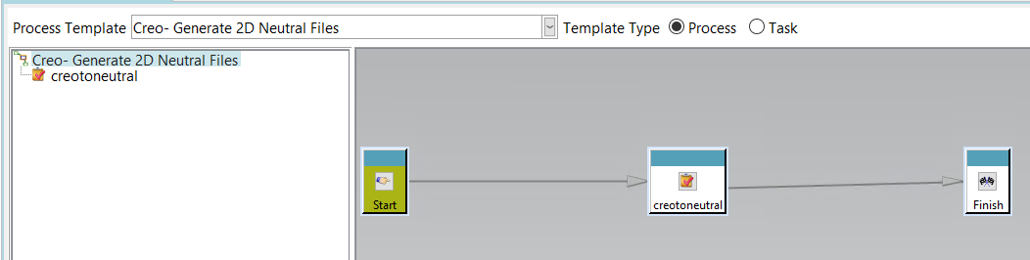

**Creo- Generate JT**

* When the Creo-Generate JT workflow is triggered on an item revision, a dispatcher request will be created
* Then the Dispatcher will process and generate a JT file for the item revision
* The generated JT file will be uploaded to the item revision Teamcenter using the **Iman_Rendering** relation

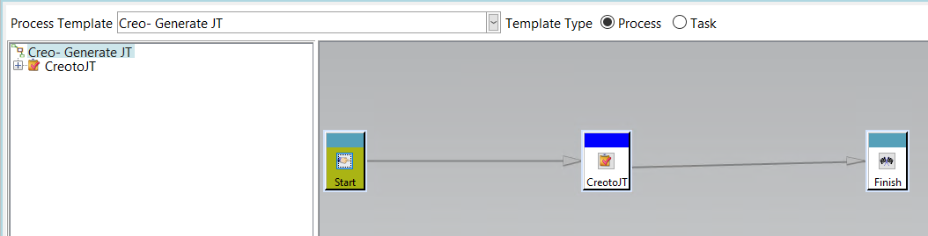

**Creo- Generate Step**

* When the Creo-Generate Step workflow is triggered on an item revision, a dispatcher request will be created
* Then the Dispatcher will process and generate an STP file for the item revision
* The generated STP file will be uploaded to the item revision Teamcenter using the **Iman_Specification** relation

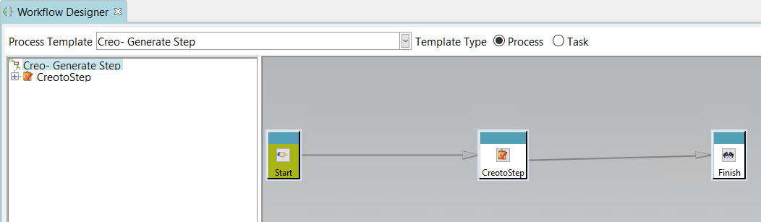

**creotopng**

* When the creotopng workflow is triggered on an item revision, a dispatcher request will be created
* Then the Dispatcher will process and generate a PNG file for the item revision
* The generated PNG file will be uploaded to the item revision Teamcenter using the **Iman_Specification** relation

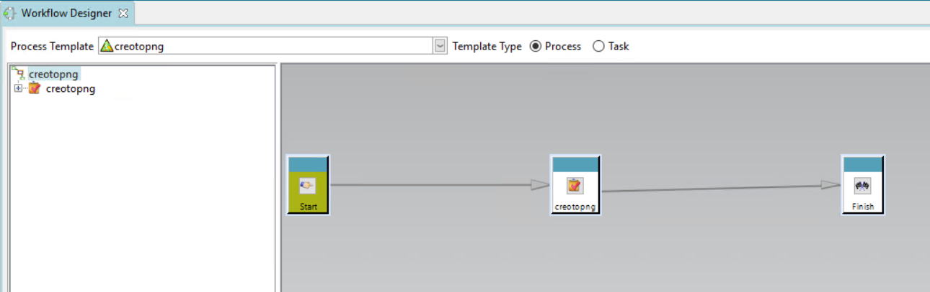

**Workflows Import to Teamcenter**

***Important Note: Please remember that the folder structure of CDEC_ Setup_Package (including all the subfolders and files) should not be changed, and it should be retained as it is***

**Importing Workflows manually into Teamcenter**

**The Creo- Generate 2D Neutral, Creo-Generate JT,** **Creo-Generate Step** and **creotopng** workflows have to be imported into Teamcenter.

So follow the below steps to manually import these 4 workflows into Teamcenter

1. Login Teamcenter as dcproxy/infodba users(must have dba privileges)
2. Go to the Workflow Designer application in Teamcenter

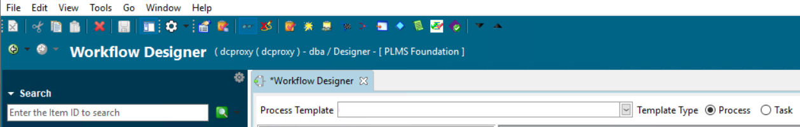

1. Click Tools à Import from the top left section of the Teamcenter

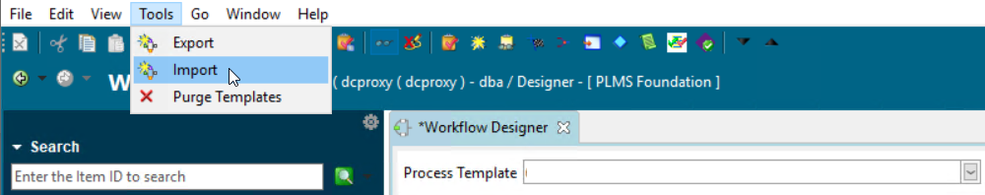

1. An import Workflow Templates dialog will appear, there select the  icon to select the import XML file

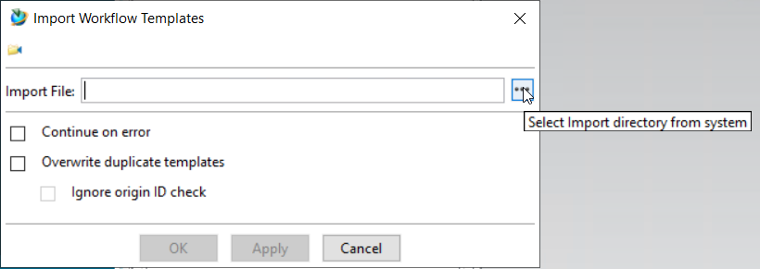

1. A file explorer dialog will then appear, where the user can select the “CreoWorkflows.xml” which is in the “**CDEC_Setup_Package\Server\pref_query_plmxml_workflow\Workflows\InputFiles”** and click **Select**

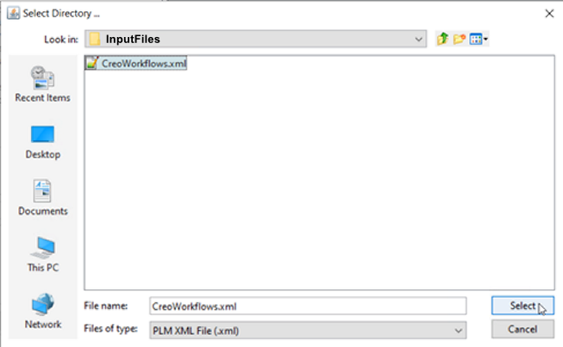

1. Check the **Overwrite duplicate templates** option

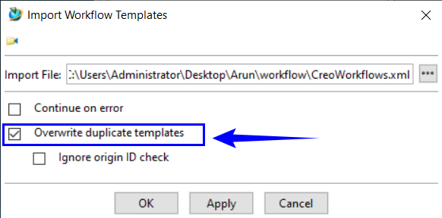

1. Click OK

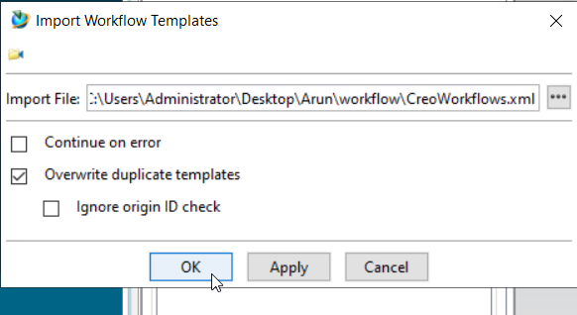

1. The workflows will now be successfully imported to Teamcenter

**Chapter 5 Dispatcher**

**Teamcenter Dispatcher**

Starting from Teamcenter 11, it is possible to configure the translator to regenerate managed Creo drawings and/or associated auxiliary files through batch, unattended procedures.

These procedures can be started regularly (e.g., nightly batch processing), triggered by workflow transitions, or explicitly triggered by the user when working in Teamcenter Rich Application Client.

**Dispatcher Client Configuration**

In the **Dispatcher** folder of the installation package copy, the **PLMSDispatcherClient.jar** file to the **lib** folder of the Dispatcher Client installed location

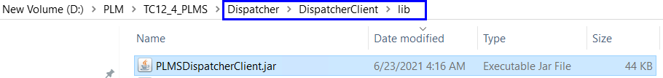

The next step is to copy the **libPLMS_Custom_TC12.dll** file from the **Teamcenter** folder in the installation package to the **bin** folder of the Teamcenter Root location of the Server and Clients.

This dll must be copied to the **TCROOT > bin** location of the Server and all the clients who are using CDEC

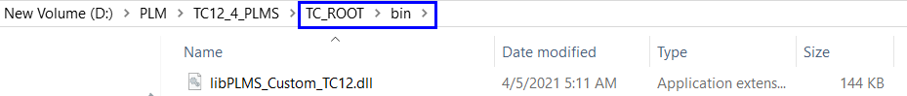

Set **TC_customization_libraries** preferenceand add **libPLMS_Custom_TC12** value in preference

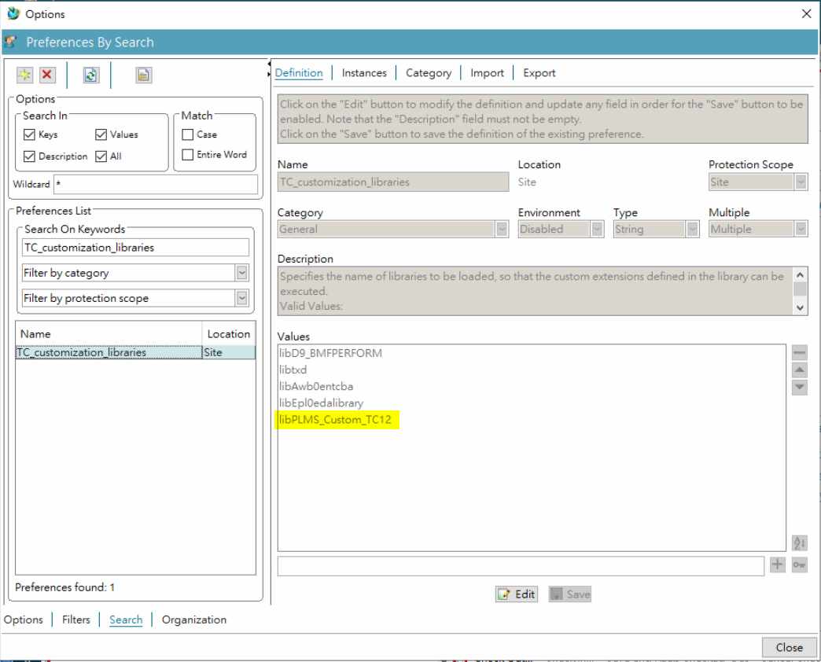

Open the installed location of the Dispatcher Client

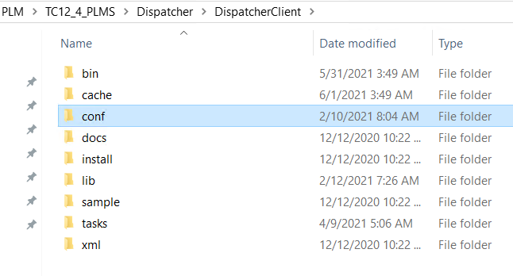

Go to the **conf** folder in **Dispatcher Client** and open the **Service.properties** using any text editor

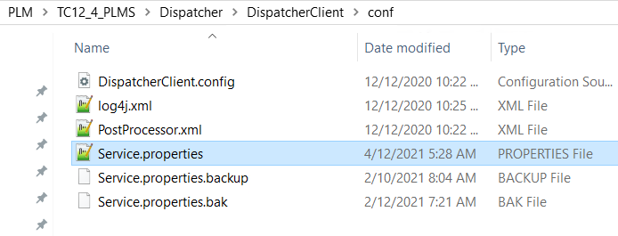

At the end of the Service.properties file add the below-mentioned lines and Check whether the translator.xml path given in the below lines is correct according to your Dispatcher Server. If the Dispatcher Module is installed on the same server as Dispatcher Client then it should be a local path but if the Module is installed on a separate server then the translator.xml path in the Service.properties should be a network path

Translator.PLMS.creotopng.Prepare=com.teamcenter.ets.custom.soldispatcherclientmod.TaskPrep

Translator.PLMS.creotopng.Load=com.teamcenter.ets.custom.soldispatcherclientmod.SOLDatabaseOperation

Translator.PLMS.creotopng.moduletranslatorxml.Path=D:\\PLM\\TC12_4_PLMS\\Dispatcher\\Module\\conf\\translator.xml

Translator.PLMS.creotoneutral.Prepare=com.teamcenter.ets.custom.soldispatcherclientmod.TaskPrep

Translator.PLMS.creotoneutral.Load=com.teamcenter.ets.custom.soldispatcherclientmod.SOLDatabaseOperation

Translator.PLMS.creotoneutral.moduletranslatorxml.Path=D:\\PLM\\TC12_4_PLMS\\Dispatcher\\Module\\conf\\translator.xml

Translator.PLMS.creotojt.Prepare=com.teamcenter.ets.custom.soldispatcherclientmod.TaskPrep

Translator.PLMS.creotojt.Load=com.teamcenter.ets.custom.soldispatcherclientmod.SOLDatabaseOperation

Translator.PLMS.creotojt.moduletranslatorxml.Path=D:\\PLM\\TC12_4_PLMS\\Dispatcher\\Module\\conf\\translator.xml

Translator.PLMS.creotostep.Prepare=com.teamcenter.ets.custom.soldispatcherclientmod.TaskPrep

Translator.PLMS.creotostep.Load=com.teamcenter.ets.custom.soldispatcherclientmod.SOLDatabaseOperation

Translator.PLMS.creotostep.moduletranslatorxml.Path=D:\\PLM\\TC12_4_PLMS\\Dispatcher\\Module\\conf\\translator.xml

After adding the lines, the Service.properties will look like the below image

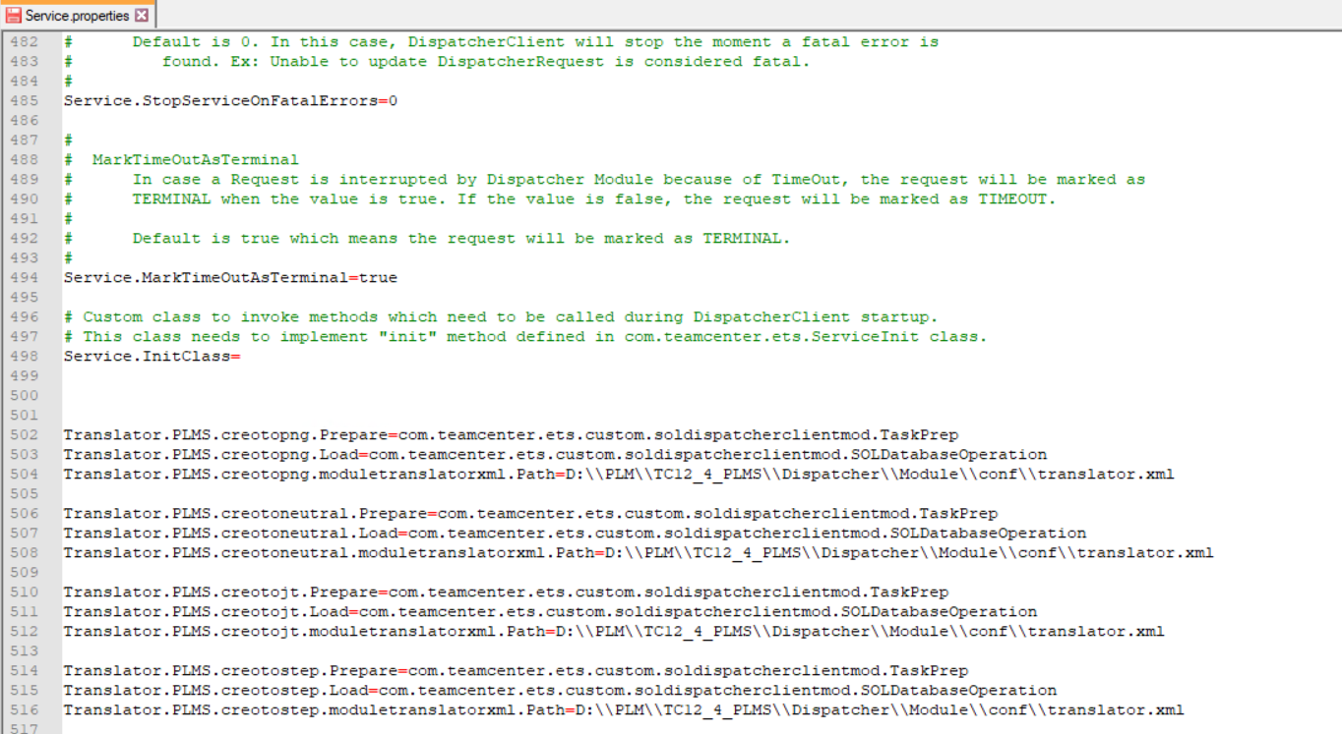

***Here the translator.xml path must be changed according to the Dispatcher module***

***The path must contain a double backslash as shown in the image***

**Dispatcher Module Configuration**

Open the installed location of the Dispatcher Module

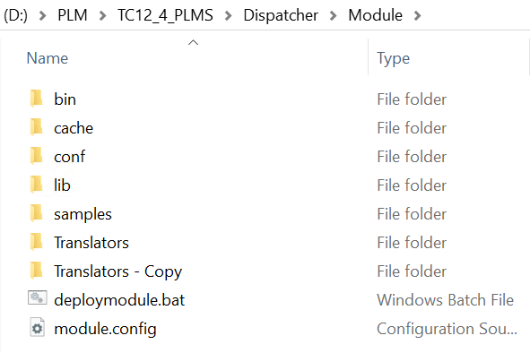

Go to the **conf** folder of **Module** and open the **translator.xml** using any text editor

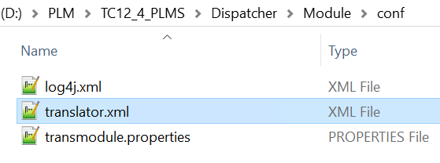

Add the add the below-mentioned lines after the <Translators> in the **translator.xml** and save the file

<!-- Configuration of creotopng -->

<creotopng provider="PLMS" service="creotopng" isactive="true">

<TransExecutable name="creotopng.bat" dir="&MODULEBASE;/Translators/creotopng"/>

<Options>

<Option name="inputpath" string=""

description="Full path to the input file or directory ."/>

<Option name="outputdir" string=""

description="Full path to the output file."/>

<Option name="OutputFileName" string="" value="output.txt"

description="Name of the output file."/>

</Options>

</creotopng>

<!-- Configuration of creotojt -->

<creotojt provider="PLMS" service="creotojt" isactive="true">

<TransExecutable name="creotojt.bat" dir="&MODULEBASE;/Translators/creotojt"/>

<Options>

<Option name="inputpath" string=""

description="Full path to the input file or directory ."/>

<Option name="outputdir" string=""

description="Full path to the output file."/>

<Option name="OutputFileName" string="" value="output.txt"

description="Name of the output file."/>

</Options>

</creotojt>

<!-- Configuration of creotoneutral -->

<creotoneutral provider="PLMS" service="creotoneutral" isactive="true">

<TransExecutable name="creotoneutral.bat" dir="&MODULEBASE;/Translators/creotoneutral"/>

<Options>

<Option name="inputpath" string=""

description="Full path to the input file or directory ."/>

<Option name="outputdir" string=""

description="Full path to the output file."/>

<Option name="OutputFileName" string="" value="output.txt"

description="Name of the output file."/>

</Options>

</creotoneutral>

<!-- Configuration of creotostep -->

<creotostep provider="PLMS" service="creotostep" isactive="true">

<TransExecutable name="creotostep.bat" dir="&MODULEBASE;/Translators/creotostep"/>

<Options>

<Option name="inputpath" string=""

description="Full path to the input file or directory ."/>

<Option name="outputdir" string=""

description="Full path to the output file."/>

<Option name="OutputFileName" string="" value="output.txt"

description="Name of the output file."/>

</Options>

</creotostep>

Before adding the following lines in the translator.xml, the contents of the file look like the below image

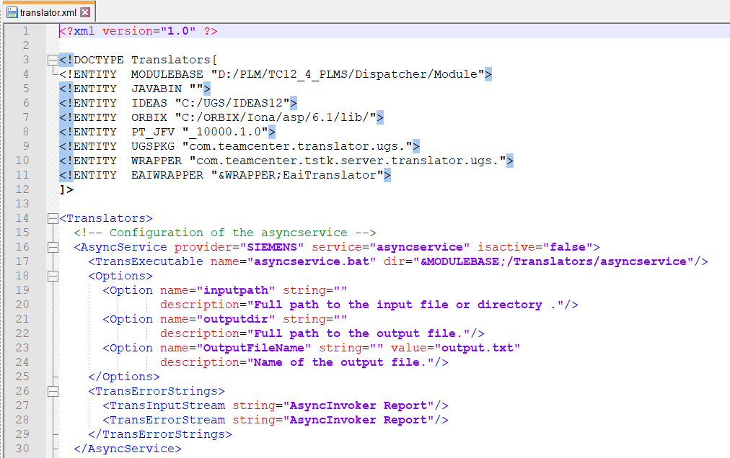

After adding the following lines and saving the translator.xml file look like the below image

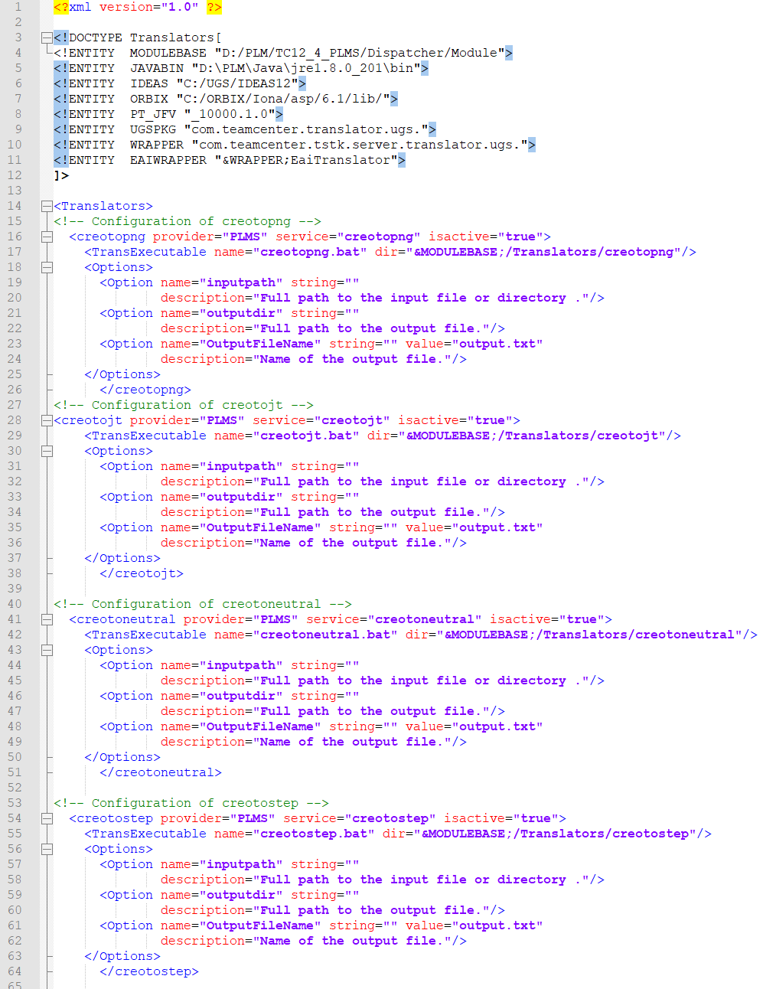

**Translators Configuration**

This topic describes the configuration of the translators to regenerate managed Creo drawings and/or associated auxiliary files through batch, unattended procedures.

The creotojt, creotoneutral, creotopng & creotostep translator folders are present in ***“CDEC_Setup_Package\Server\Translators”***

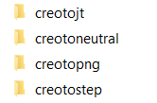

These folders should to copied to the Translators folder present in the Module folder of Dispatcher***(Eg. {Teamcenter_install_location}/Dispatcher/Module/Translators)*** in the Teamcenter server where the Dispatcher Module is installed

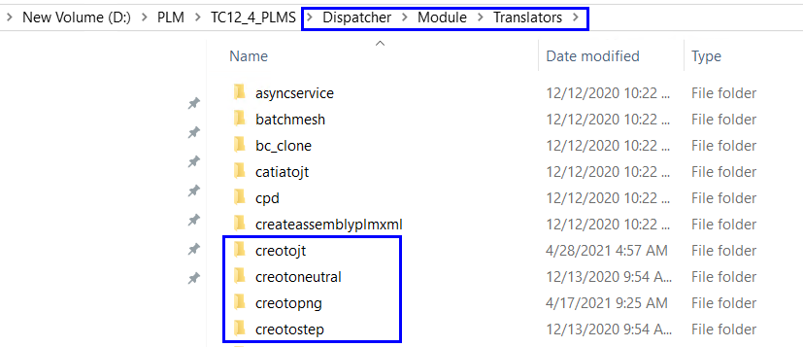

Each translator folder contains a batch file(.bat) that will be configured already in the provided ***CDEC_Setup_Package***. Below is the information on the batch file(.bat) present in each translator folder

**Creo to JT**

In the creotojt folder open the **creotojt.bat** in notepad++ or any other text editor application.

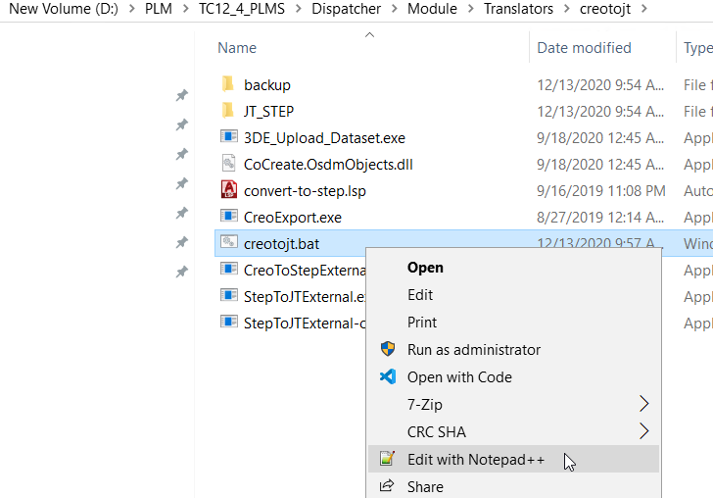

In the **creotojt.bat** check whether the values of **TC_ROOT** and **TC_DATA** under a section **set TC Environment Variables** according to the Dispatcher Server. If they are not the same then edit those values and **Save** the file

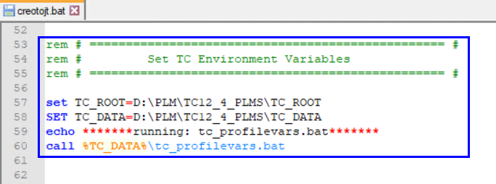

**Creo to Neutral**

In the creotoneutral folder open the **creotoneutral.bat** in notepad++ or any other text editor application

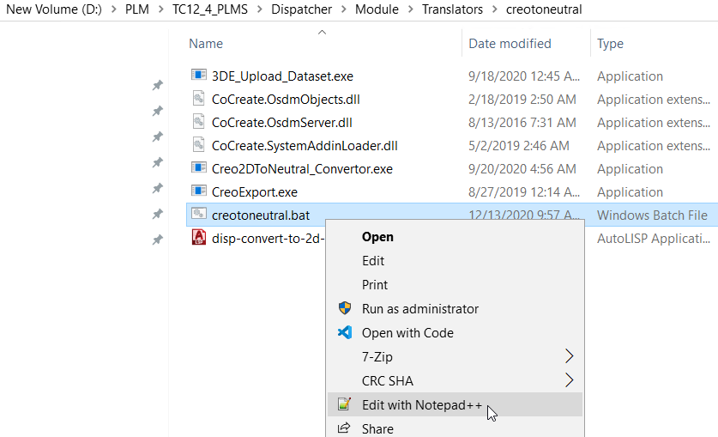

In the **creotoneutral.bat** check whether the values of **TC_ROOT** and **TC_DATA** under a section **set TC Environment Variables** according to the Dispatcher Server. If they are not the same then edit those values and **Save** the file

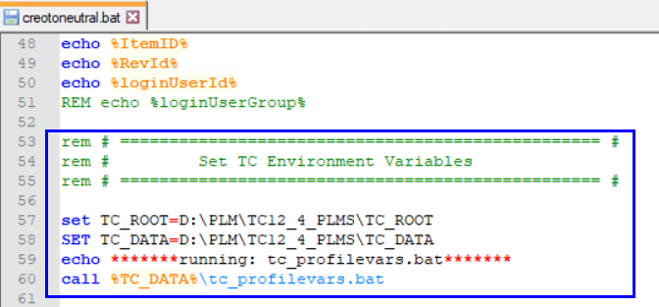

In the **creotoneutral.bat** file, there will be a line for calling the Creo2DToNeutral.exe along with the arguments. The arguments after the group(**dba**) the Dataset real name(**PDF**) Named reference type (**PDF_Reference**) Relation(**IMAN_specification**) – for PDF these values have to be checked.

Then following the arguments for PDF, the arguments for DXF must be checked Dataset real name(**DXF**) Named reference type (**DXF_Reference**) Relation(**IMAN_specification**)

Then finally after the arguments for DXF, the arguments for DWG has to check Dataset real name(**Anv3DWG**) Named reference type (**Anv3DWG_Reference**) Relation(**IMAN_specification**)

The above-mentioned arguments change according to the client’s Teamcenter data model

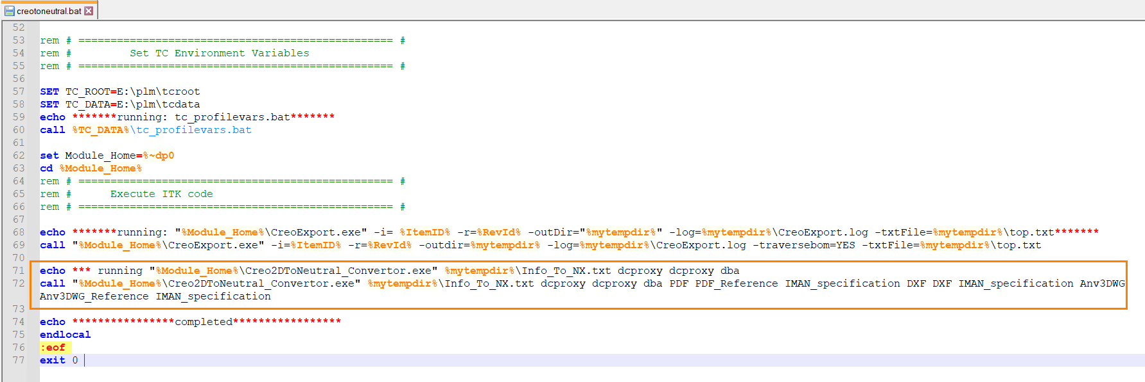

**Creo to PNG**

In the creotopng folder open the **creotopng.bat** in notepad++ or any other text editor application

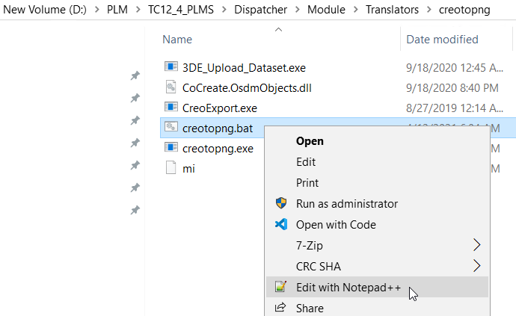

In the **creotopng.bat** check whether the values of **TC_ROOT** and **TC_DATA** under a section **set TC Environment Variables** according to the Dispatcher Server. If they are not the same then edit those values and **Save** the file

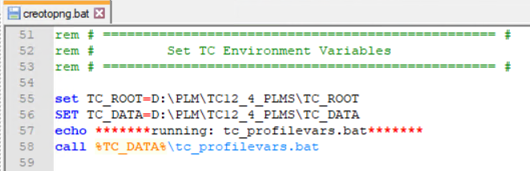

**Creo to STEP**

In the creotostep folder open the **creotostep.bat** in notepad++ or any other text editor application

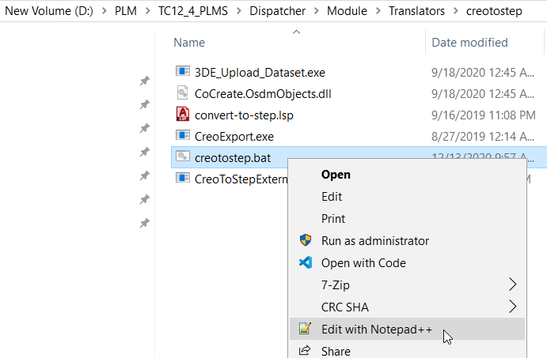

In the **creotostep.bat** check whether the values of **TC_ROOT** and **TC_DATA** under a section **set TC Environment Variables** according to the Dispatcher Server. If they are not the same then edit those values and **Save** the file

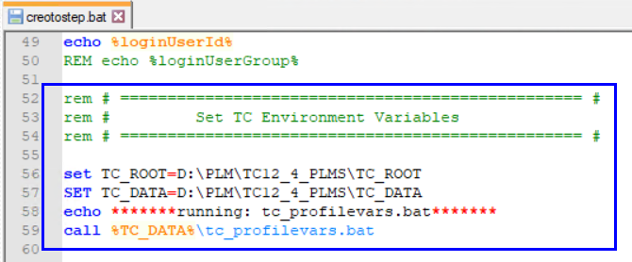

In the **creotostep.bat** file, there will be a line for calling the CreoToStepExternal.exe along with the arguments. The arguments after the group(**dba**) the Dataset real name(**Anv3STEP**) Named reference type (**Anv3STEP_Reference**) Relation(**IMAN_specification**) – for PDF these values have to be checked.

The above-mentioned arguments change according to the client’s Teamcenter data model

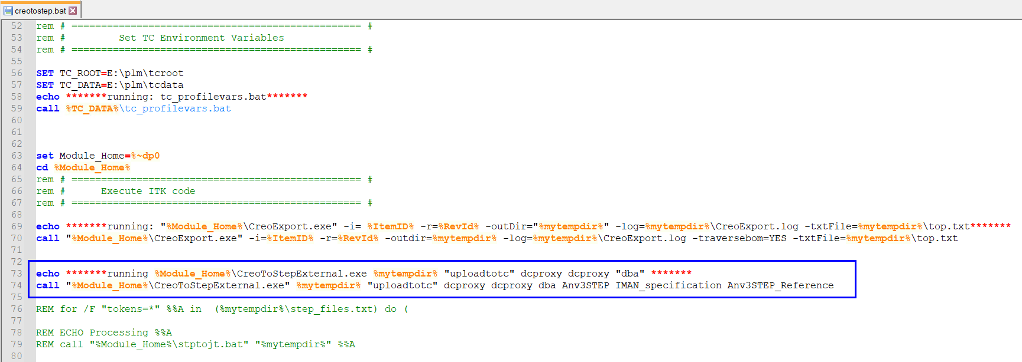

***Note: Kindly Do these changes to the Dispatcher and Translators during the off hours and also restart the Dispatcher Scheduler, Dispatcher Client & Dispatcher Module after the configurations are done.***

**Chapter 6 PLM/XML Transfer**

This chapter describes how to import the PLM/XML Transfer mode into Teamcenter

***Important Note: Please remember that the folder structure of CDEC_ Setup_Package (including all the subfolders and files) should not be changed, and it should be retained as it is***

**Importing Transfer Modes manually into Teamcenter**

1. Close the PLM XML Administration module in Teamcenter before export or import of transfer mode.
2. Copy the Transfer mode file which will be present in “**CDEC_and_CDAT\CDEC_ Setup_Package\Server\TransferMode\**” to the desired location in your local system. Inside this TransferMode folder, there are three XML files\

* **CDEC_BOM_Export**
* **CDEC_BOM_Export_Witout_Datasets**
* **CDEC_BOM_Export_Witout_Datasets_TcXML**

1. These 3 files are the input files for importing the Transfer Modes
2. Open Teamcenter command prompt
3. Then go to the bin location in the Teamcenter command prompt

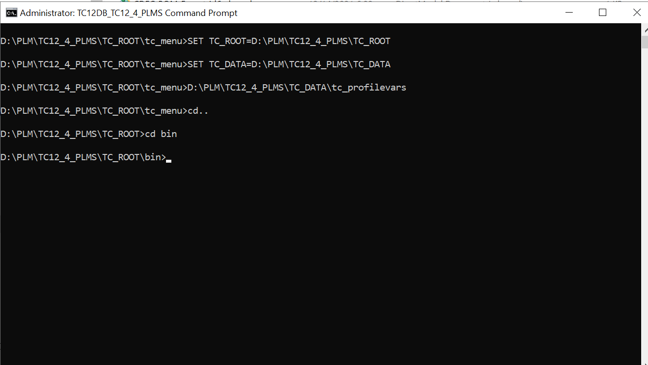

1. In bin location run **plmxml_import.exe** utility with the following arguments as shown below

plmxml_import.exe -u=<USERID> -p=<PASSWORD> -g=dba -xml_file=<XML File> -import_mode=overwrite

in the “**xml_file**” argument make sure you mention the path of the location where the transfer mode XML file is present, In the transfer mode argument you have to pass the name of the transfer mode, In import_mode you have to mention overwrite and Run utility

1. The admin has to run three times separately for importing the three XML files
2. The imports must be completed without any errors
3. You can see the imported transfer mode in the PLM XML Administration module.

Below is the sample image showing how the command line for import looks like in a command prompt

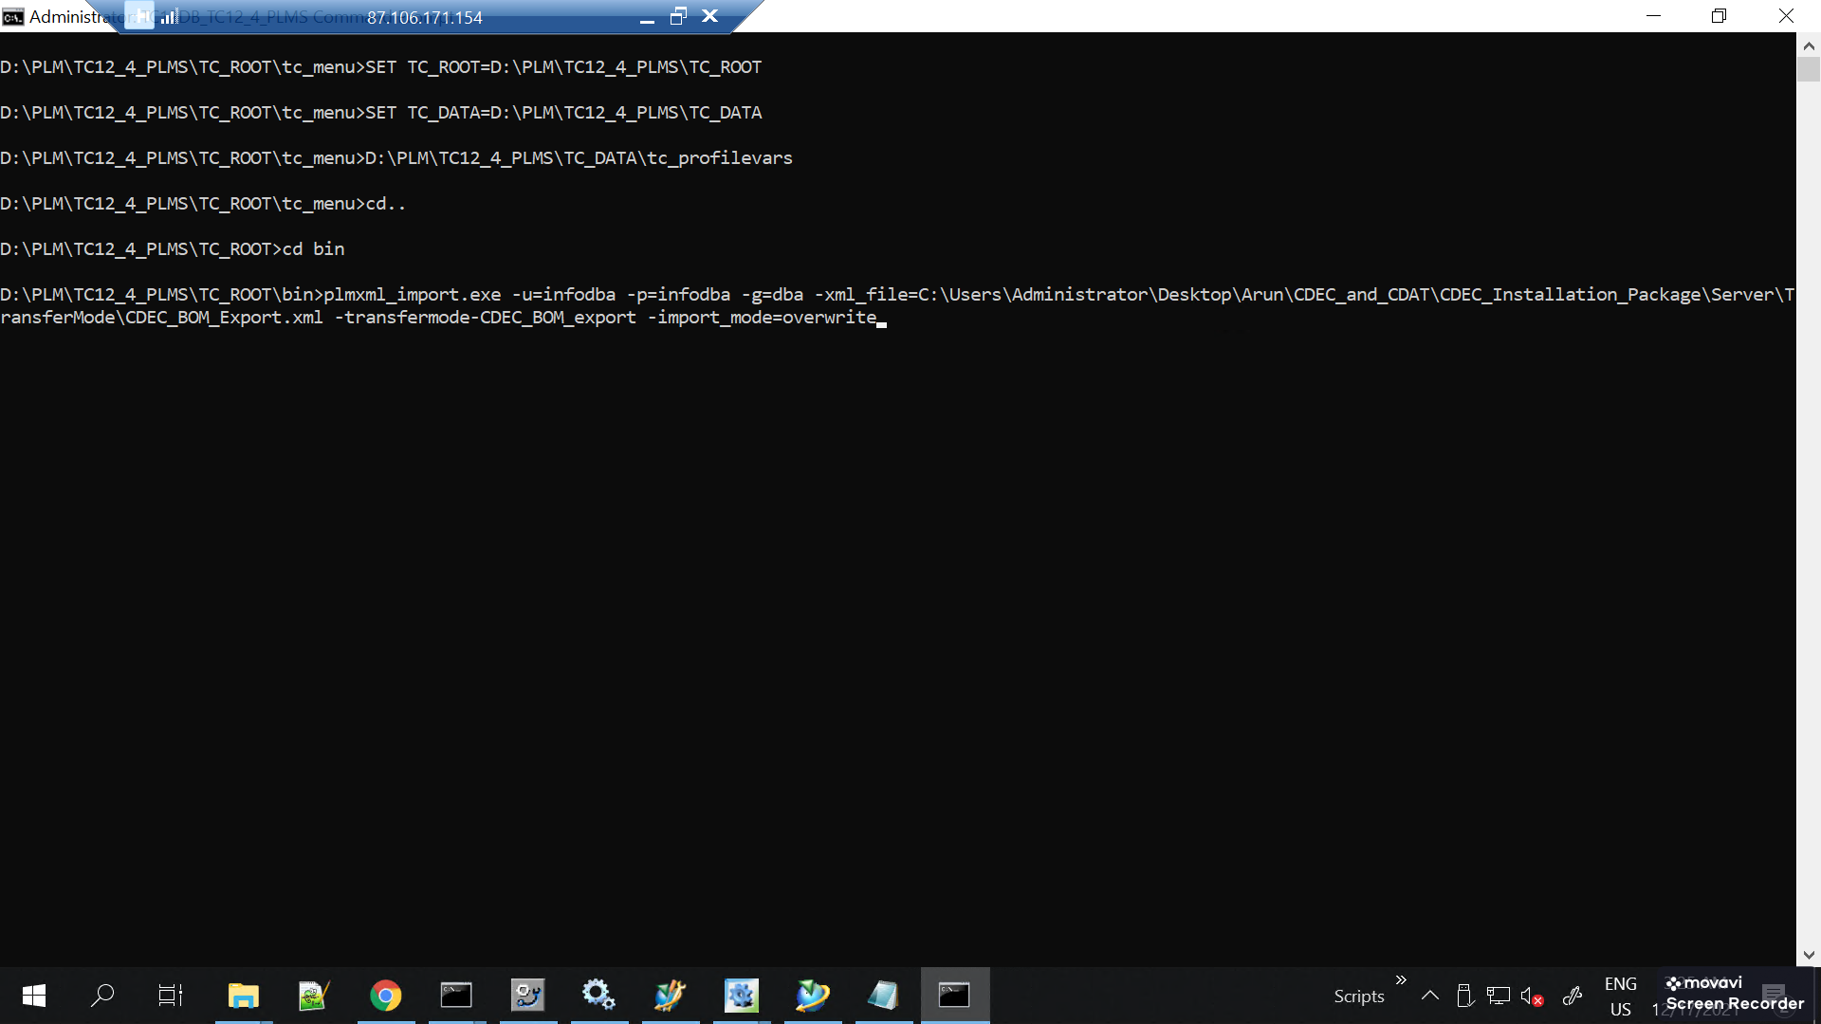

**Chapter 7 Queries**

This chapter describes how to import Teamcenter queries XML file provided by PLMS

**Importing Queries**

***Important Note: Please remember that the folder structure of CDEC_ Setup_Package (including all the subfolders and files) should not be changed, and it should be retained as it is***

**Importing Queries manually into Teamcenter**

1. In the **Server** folder of the **CDEC_ Setup_Package** Go to the pref_query_plmxml_workflow\Queries\InputFiles
2. Users can see the following files inside the Queries folder

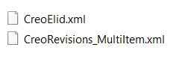

1. Go to the **Query Builder** module

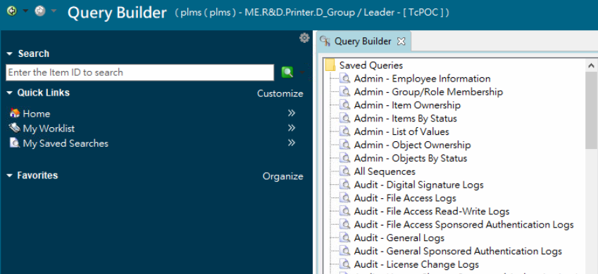

1. Click on the **Import** button and click the ‘**…**’ icon to select the files to import

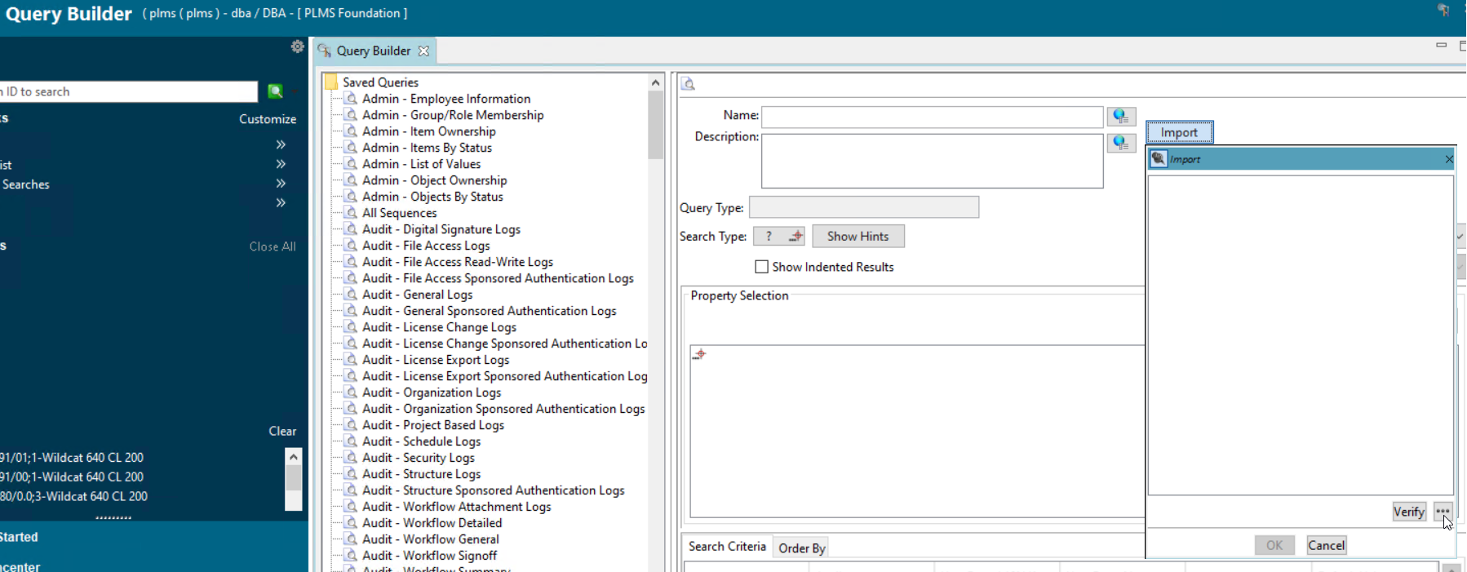

1. Select one XML file and click import

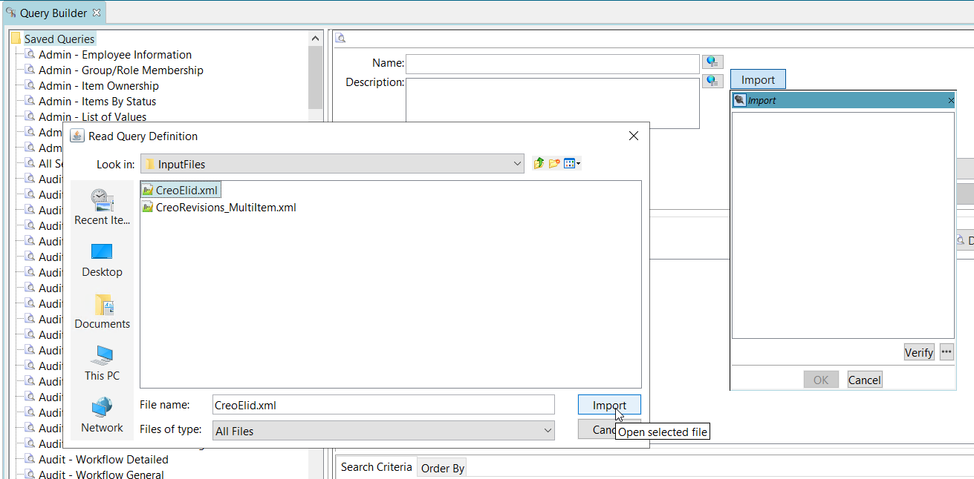

1. After this click on Verify to verify the query format

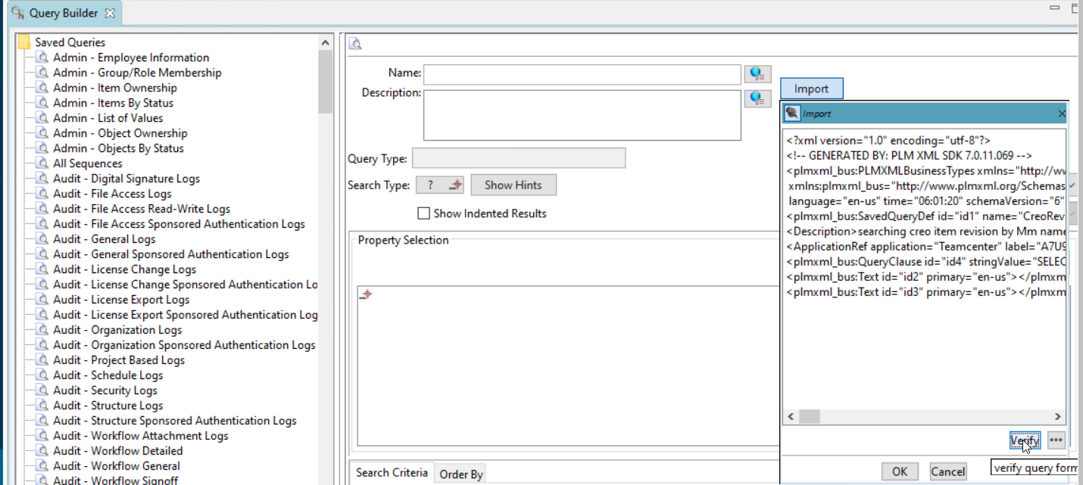

1. Now click OK to import the query into Teamcenter

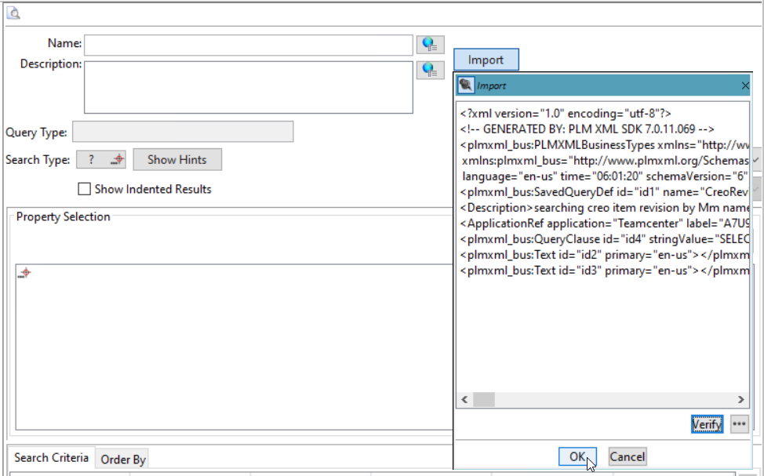

1. Similarly, repeat steps 4 to 7 for other queries also **CreoRevisions_MultiItem...**
2. Once this is completed then all three queries will be successfully imported to Teamcenter

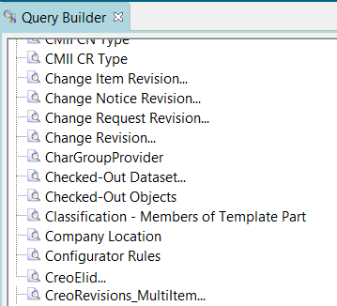

1. Users can open Teamcenter Rich Client and check for the **CreoElid…, CreoRevisions_MultiItem...** in the Search
2. After the successful import of the queries select **CreoElid…** query in the left panel of the query builder

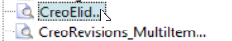

Then in the right panel select the Revision Rule value as Latest by Creation Date from the drop-down list and click **Modify** to save the changes

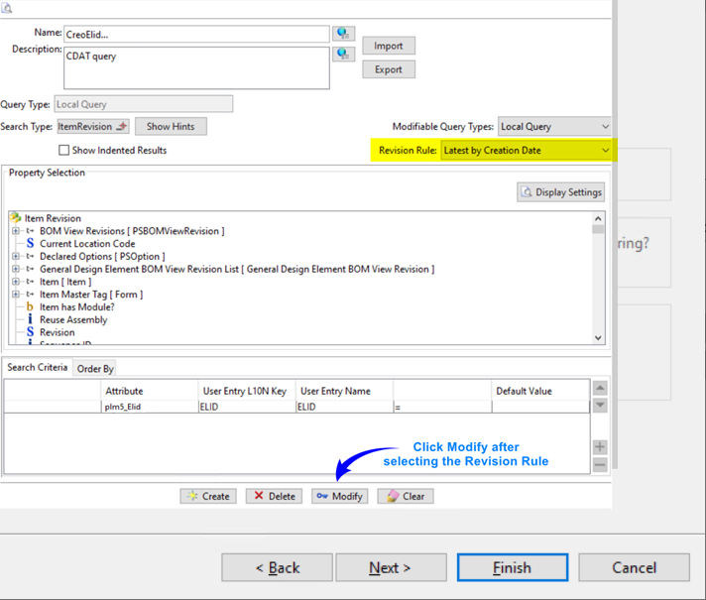

1. Select the **CreoRevisions_MultiItem...** query in the left panel of the query builder

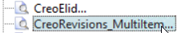

Then in the right panel select the Revision Rule value as Latest by Creation Date from the drop-down list and click **Modify** to save the changes

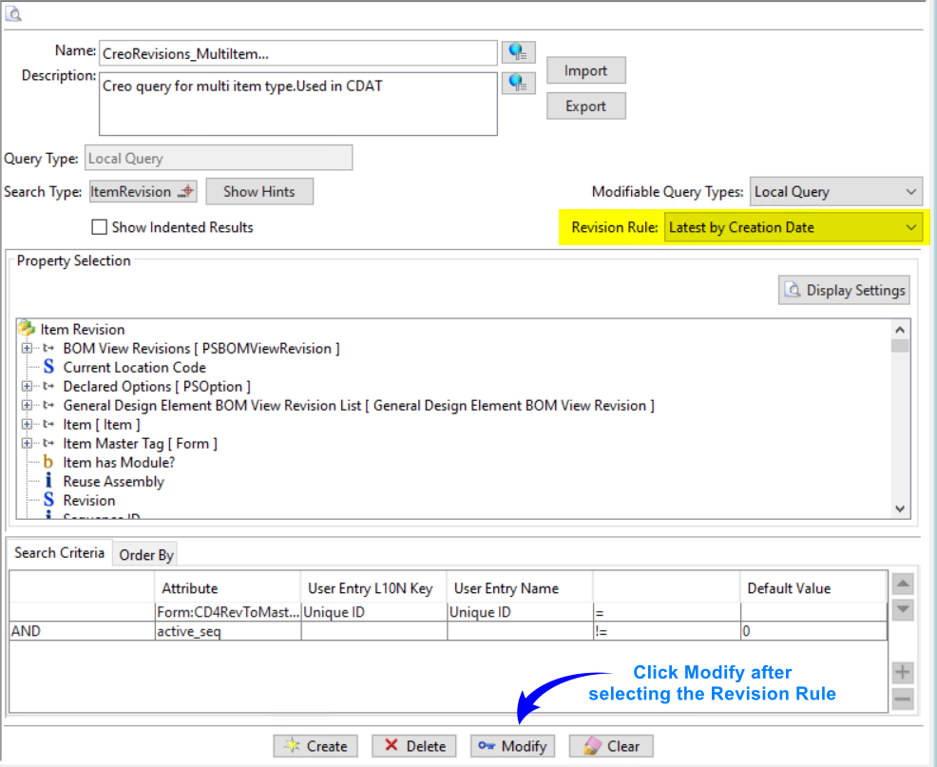

1. If a value is given in the **CD4_CDAT_UniqueAttr** preference then this value has to be changed in the **Search Criteria** tab of the **CreoElid…** query.

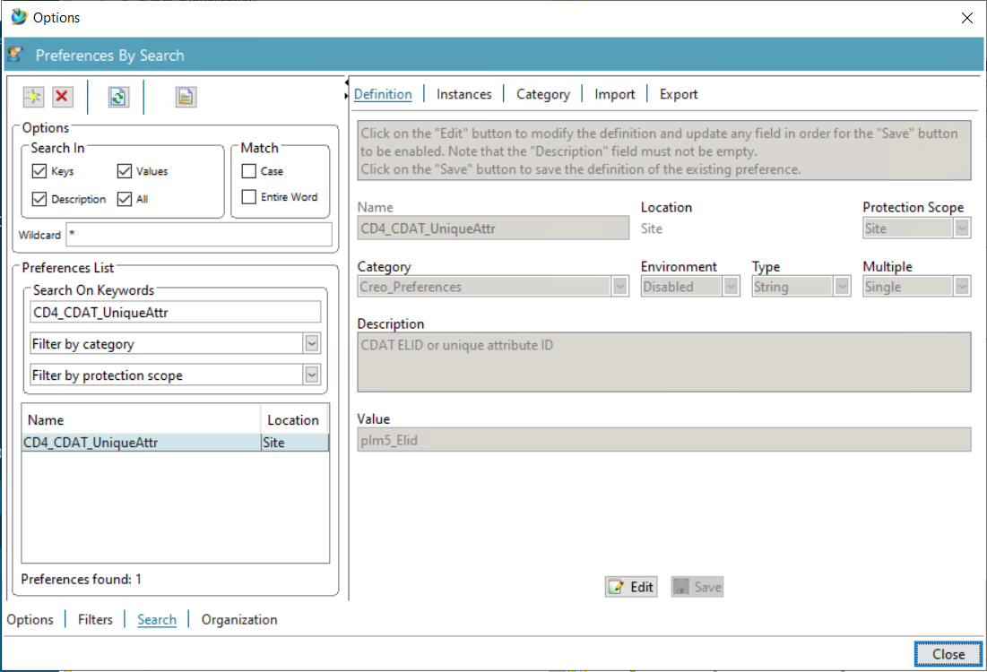

1. If the data model does not have any Elid property then make the **CD4_CDAT_UniqueAttr** value empty and if the value here in this preference is made empty then no need to make any changes in the Search Criteria of the CreoElid… query

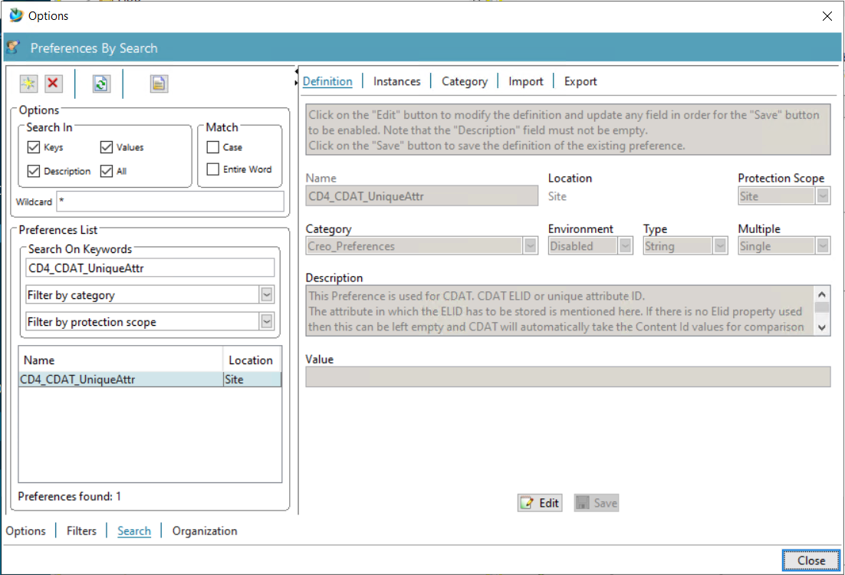

**Chapter 8 CDEC License Server Setup**

This chapter describes how to setup CDEC License Server

**CDEC License Setup**

This topic describes how to set up a Creo Elements Direct Embedded Client License. This step must be **performed before installing the Creo Direct Embedded Client(CDEC)**

1. The **CDECLicenseServer** folder in the **CDEC_ Setup_Package** **\Server** containing the following license setup files must be kept in the local drive of a server.

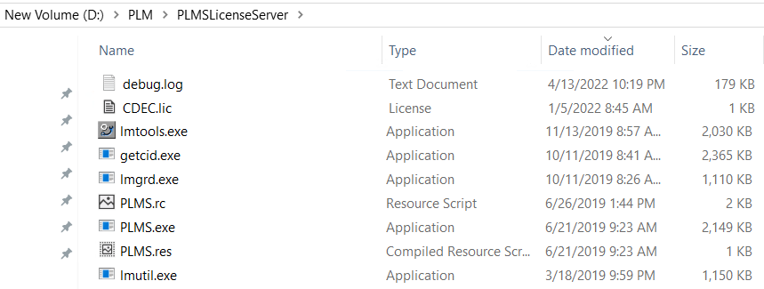

1. Launch the lmtool.exe as administrator from this location or the Start menu

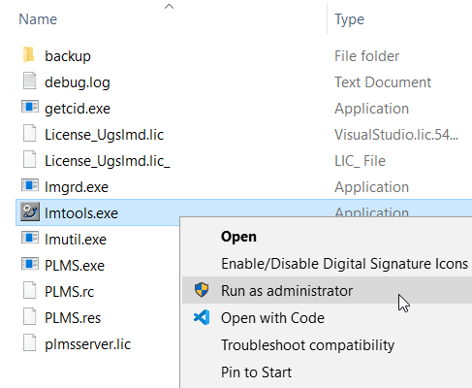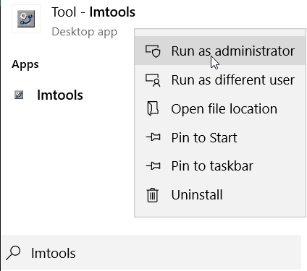

1. Go to **Service/License File** tab and select the “**Configuration using Services”** option

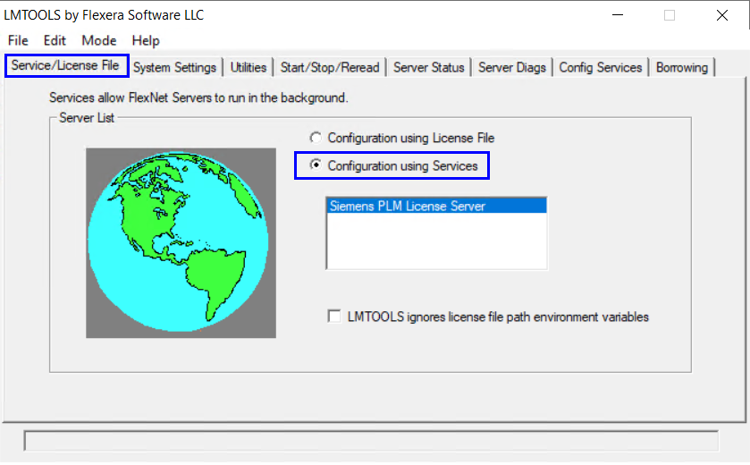

1. Select the **Config Services** tab and enter a Service Name(Eg. Here I have used **CDEC**)

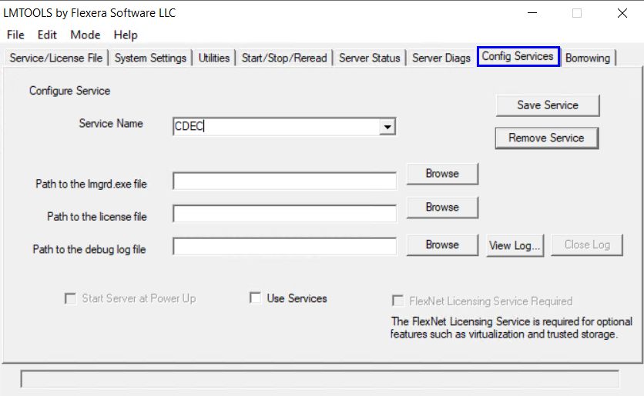

1. Click the **Browse** button for locating the **Path to the lmgrd.exe file**

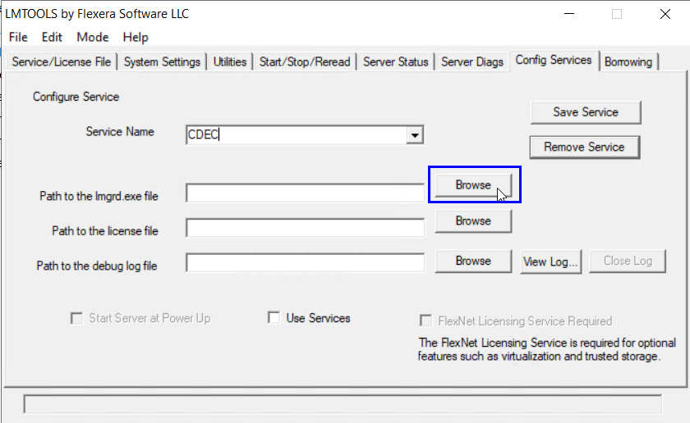

1. From the **CDEC License Folder** select the **lmgrd.exe** and click open to load the exe in the lmtools dialog.

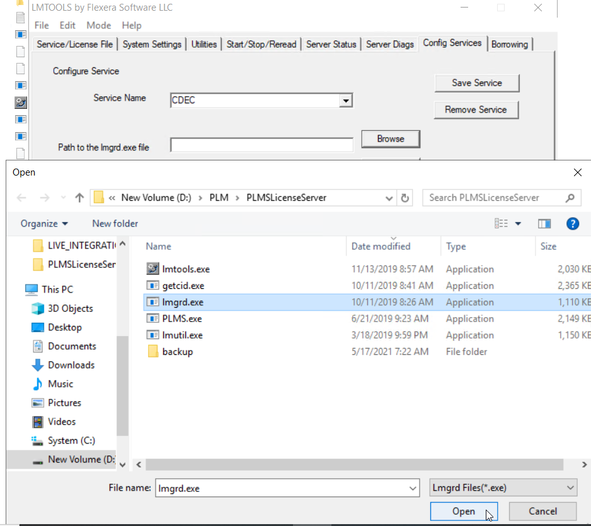

1. Click the **Browse** button for locating the **Path to the license file**

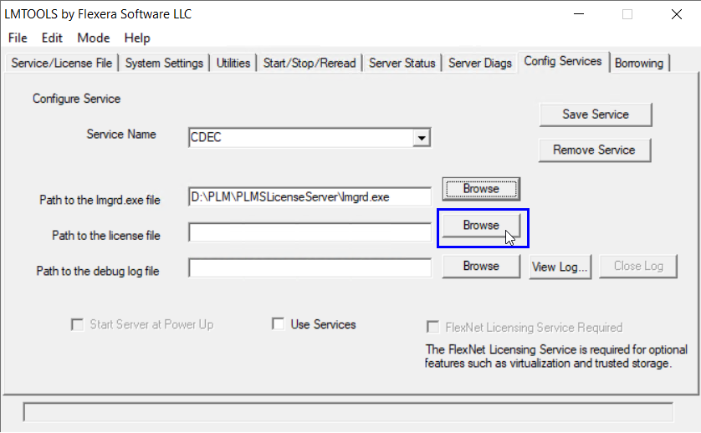

1. From the **CDEC License Folder** select the **CDEC.lic** and click open to load the CDEC license file in the lmtools dialog.

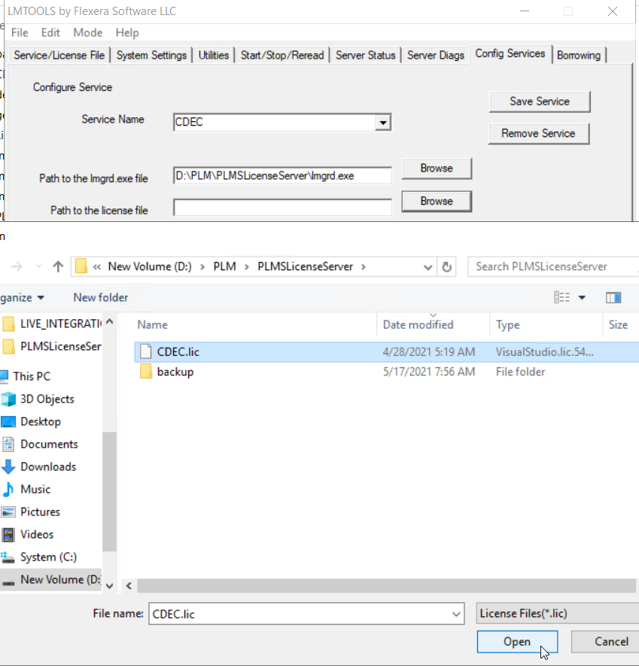

1. Click the **Browse** button for locating the **Path to the debug log file**

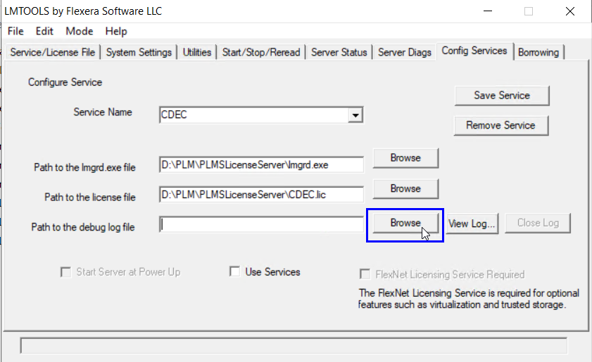

1. From the **CDEC License Folder** select the **debug.log** and click open to load the debug log file in the lmtools dialog.

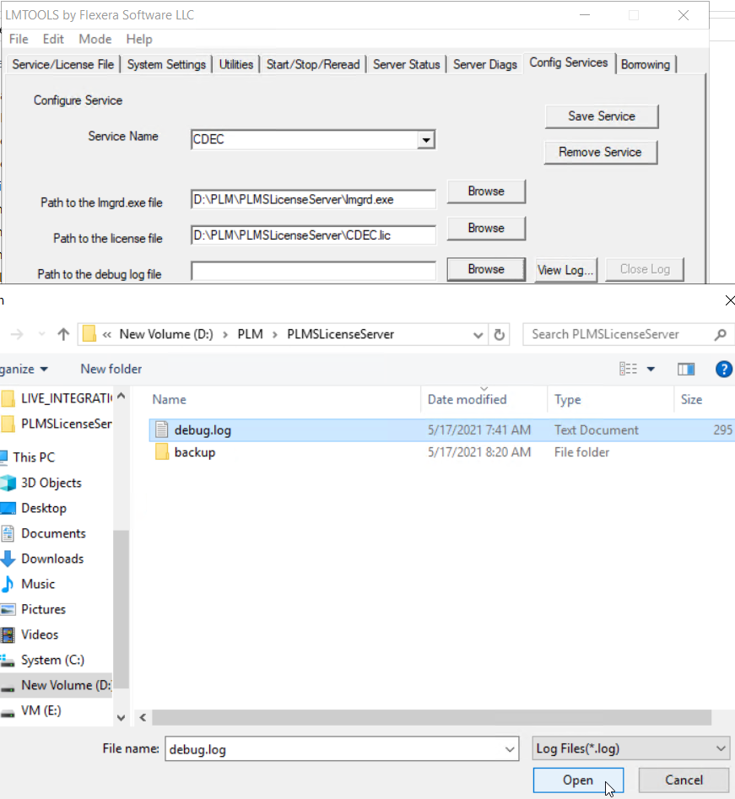

1. Click **Save** **Service** to create a new service

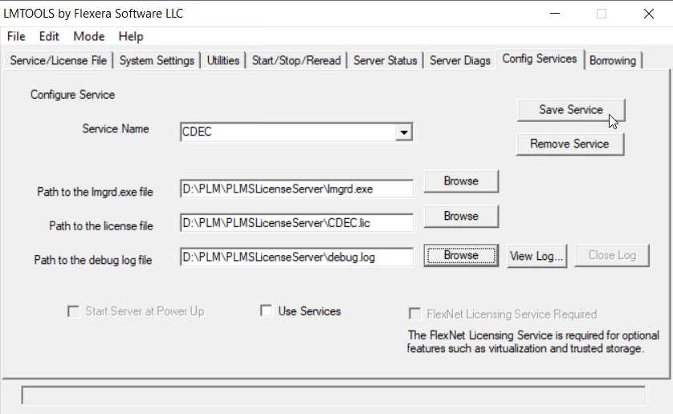

1. Click **Yes** to save the settings for the service: CDEC

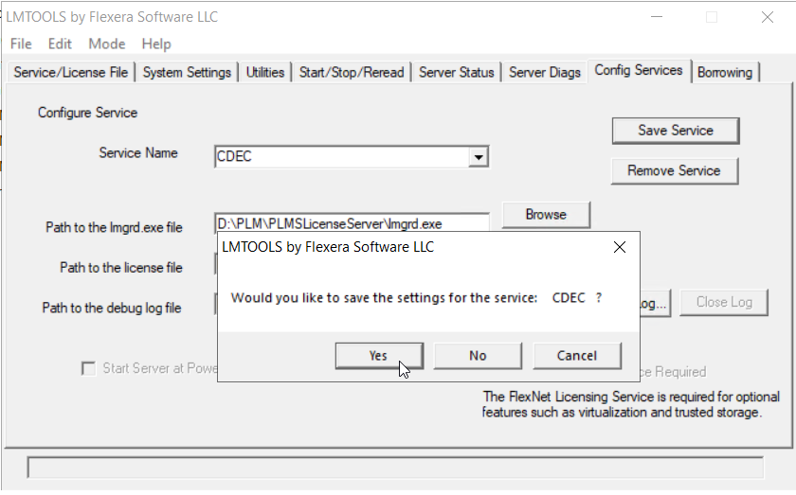

1. The new service CDEC is created

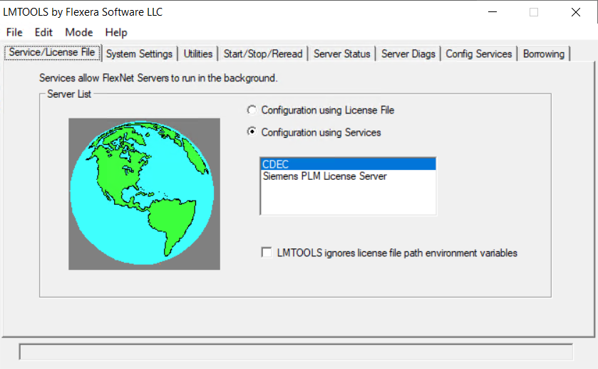

1. By selecting the **CDEC** service, then go to the **Server Status** tab and click **Perform** **Status Enquiry**

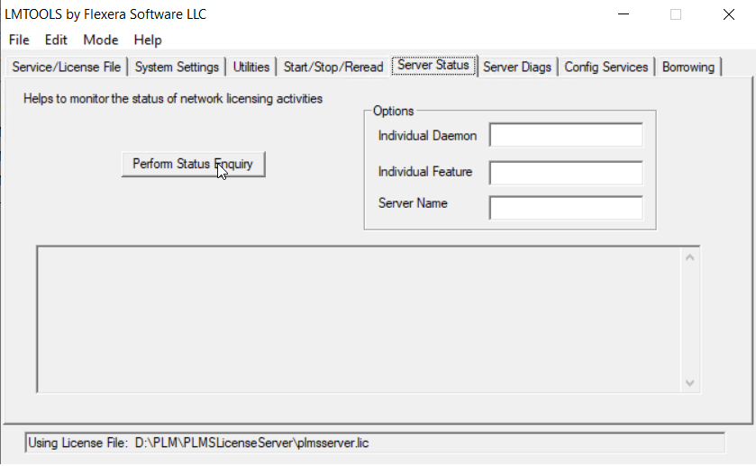

1. The status of How many CDEC licenses are issued and how many are in use will be shown

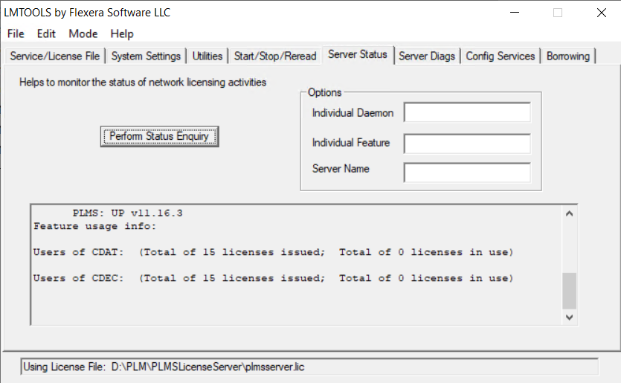

1. Now the user can open **Creo Elements** and then start using **CDEC features** after the installation of CDEC.

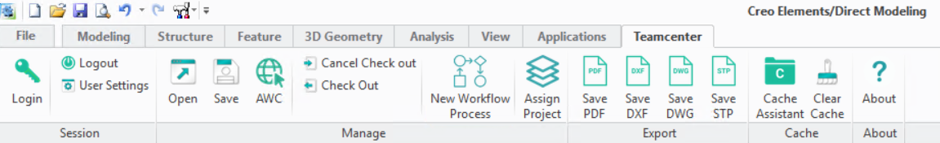

**Chapter 9 AWC Configuration**

This chapter describes how to install custom modules provided by PLMS

**Install addPartToCreo** & **openInCreo**

This installation must be done in the server where the AWC is installed

1. Go to the TCROOT location in the server where the AWC is installed

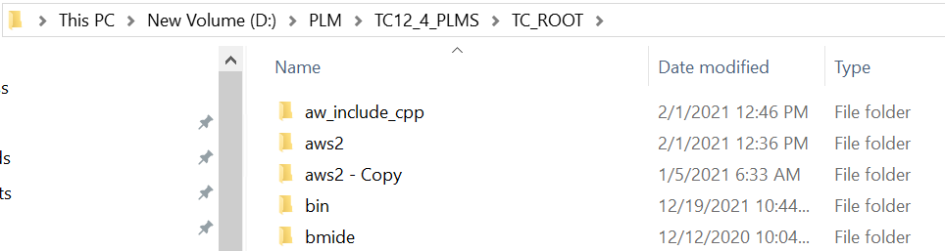

1. Go to the aws2\stage\src path in TCROOT

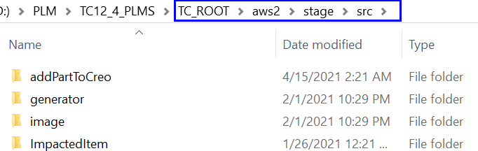

1. Copy the **addPartToCreo** & **openInCreo** folder from “C:\plms” in server 245 and paste it into this location “TCROOT\aws2\stage\src” of the AWC installed server

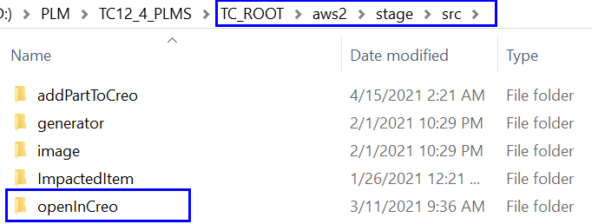

1. Now go to “TCROOT\aws2\stage\src\solution” and open **kit.json** in any text editor, preferably Notepad++

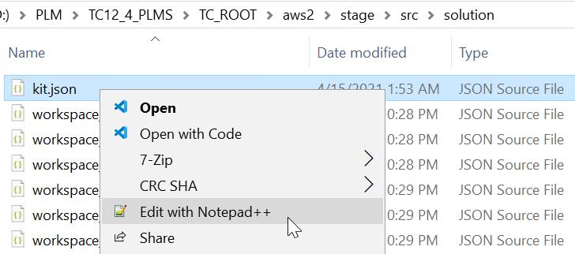

1. In the modules section of the tc-aw-solution add “**,** “ at the end of the last value excluding the double quotes as shown in the image

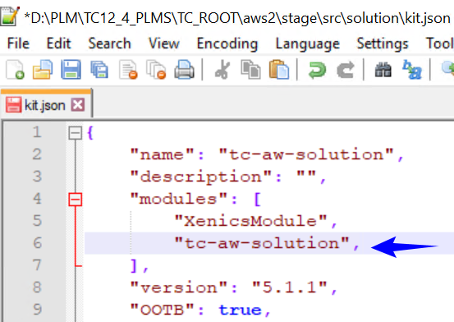

1. In the modules section of the tc-aw-solution add the “**addPartToCreo”** value along with the double quotes and then add a comma(,) as shown in the image

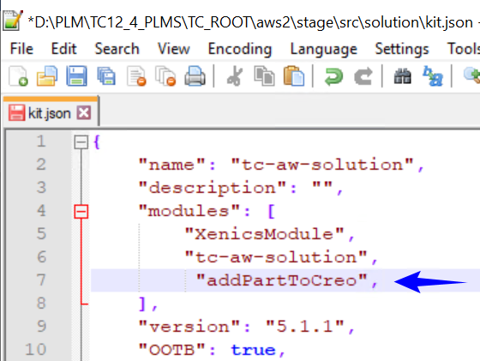

1. Below the **addPartToCreo** value add the **“****openInCreo”** value including the double quotes as shown in the image and **Save** the file

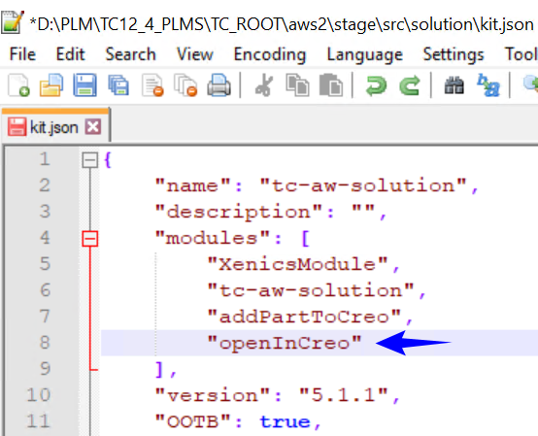

1. Now go to the location **TCROOT\aws2\stage** and run the **awbuild.cmd** as administrator

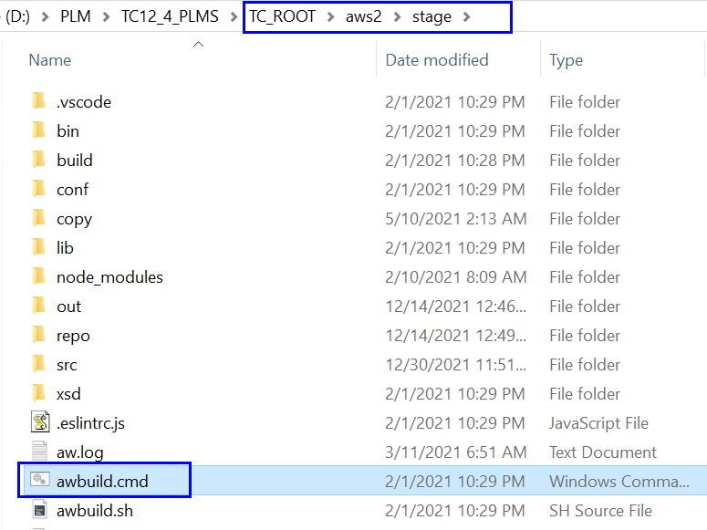

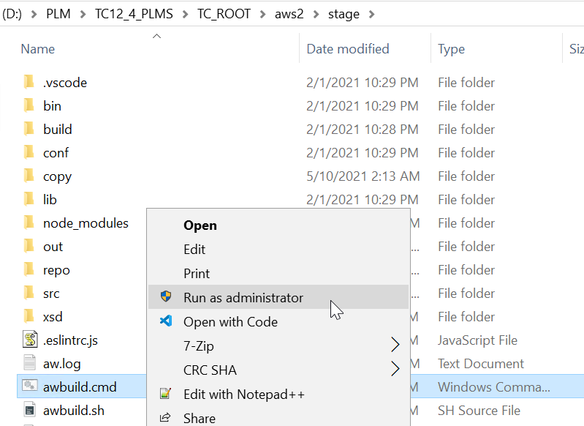

1. After running the awbuild.cmd, **restart the Teamcenter web services**
2. Now open AWC and open a Design item revision with the Creo Package dataset in it and then in the Open option user will see the two options **Add Part to Creo** & **Open In Creo**

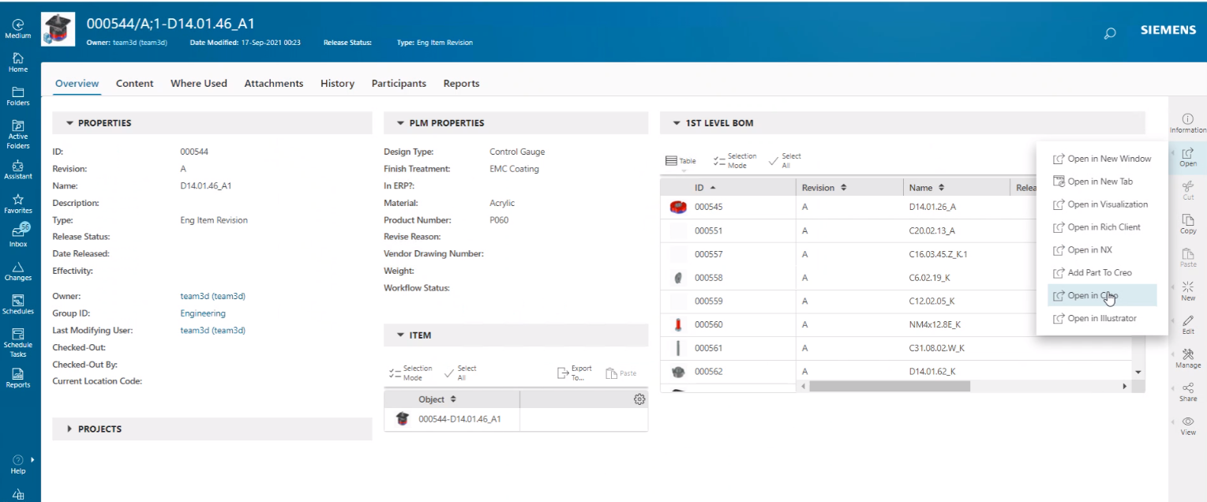

**Client Activities**

**Chapter 10 Creo Direct Embedded Client**

This chapter describes how to install Creo Direct Embedded Client(CDEC)

**Installing Creo Direct Embedded Client(CDEC)**

Before installing the CDEC, it is mandatory to go through the section about system requirements and software prerequisites for CDEC. This installation needs to be done in the client machine where the user wants to use CDEC.

**For CDEC installation, Please refer to the installation document which will be provided separately**

**Chapter 11 How to…?**

This chapter describes how to configure Creo Direct Embedded Client(CDEC)

**Open in Creo Configuration**

Following Steps For OpenInCreo Configuration will be carried out during the CDEC Installation process and this is just for information

1. Jar file named “**OpenInCreo.jar**” will be automatically copied during the CDEC installation process to “**TC_ROOT\portal\plugins\OpenInCreo.jar**” in your local system.
2. **Open_In_Creo** system environment variable will be automatically created Next step is to check Environmental Variable.

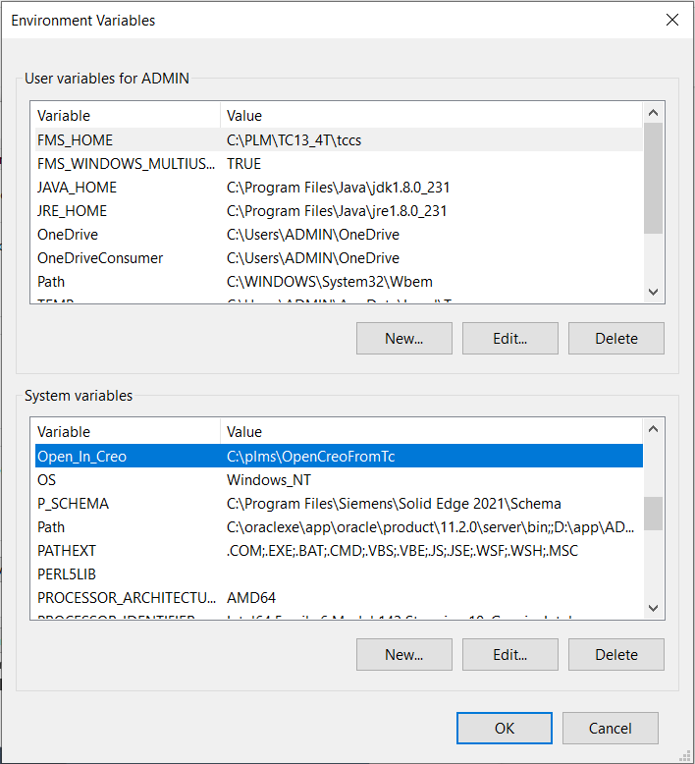

1. **genericxml.bat** in TC_ROOT\portal\registry will be run during the CDEC Installation procedure.

**Configuration of teamcenter.properties**

There are a configuration file called “teamcenter.properties” in the **Creo_TC_Live_Integration** folder of **AddIns** which will be created during the CDEC installation inside the **personality** folder of the **Creo** installed location

This file contains the following information

*TC_SERVER_HOST*

*TC_FSC_HOST*

*TC_AWC_HOST*

Using this information the CDEC will connect to the TC Server and AWC

The user can change this information if he wants the CDEC to connect to a different TC server

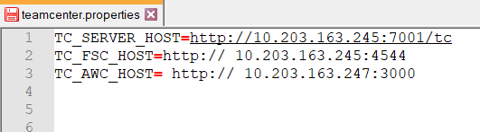

Common issues

1. If a user receives a “No CDEC License” error during the login of CDEC - Check whether **cdec_lic.exe is** running in the details tab of the task manager then terminate the **cdec_lic.exe** to release the locked CDEC license. **(*Refer to the image attached under point number 3 in this section*)**
2. If a user receives a “Maximum users exceeded” error then **Perform Status Enquiry** in **lmtools** and check whether the numbers of licenses provided are completely in use – check whether the number of licenses in use is equal to the number of users using the CDEC currently

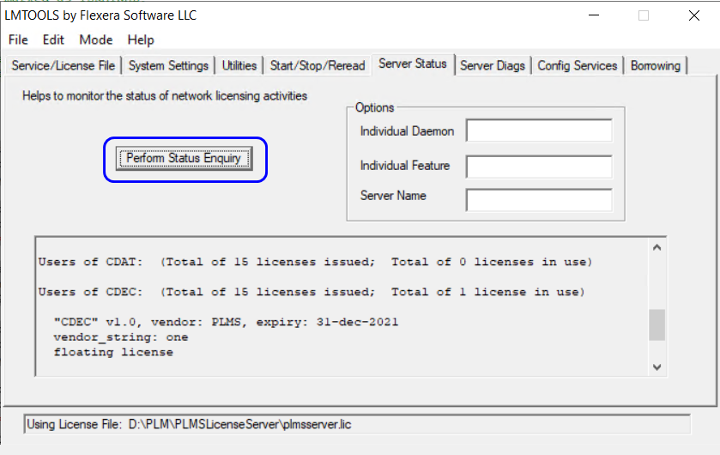

1. This can be fixed by restarting the CDEC License Server.
   1. The procedure to do this activity is to go to **Start/Stop/Reread** tab in the lmtools and click on the **Stop Server** button. The status will go from “*Stopping Server Requested*” message to “*Stopping Server*”.

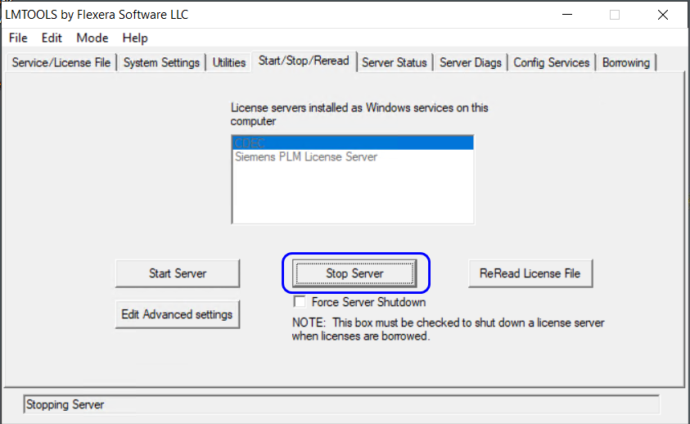

* 1. After this click on **Start Server** to start the CDEC License server and the status will show “*Start Server Successful*”

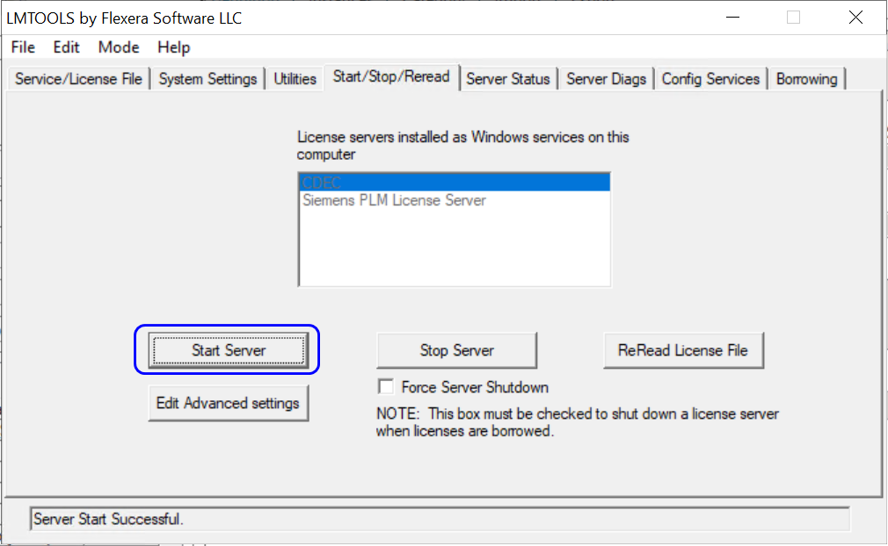

* 1. Then again **Perform Status Enquiry** in the **Server Status** tab to check whether the CDEC License is available

1. If the CDEC is crashed unexpectedly then go to the Details tab in the task manager and terminate the **cdec_lic.exe** to release the locked CDEC license.

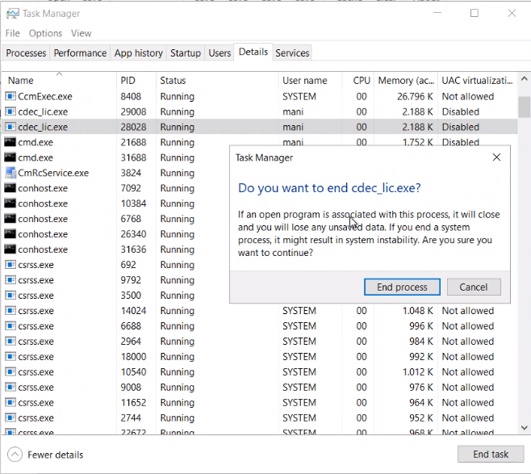

**Warning:**

Do not terminate the **cdec_lic.exe** while working in the CDEC, this could affect the user to perform Teamcenter functionalities from Creo.

Document History

|  |  |  |  |
| --- | --- | --- | --- |
| Revision | Date | Author | Description |
| 5.2 | 03 August 2021 | Arun Vignesh | Initial & Commercial Version Document |
| 5.3 | 15 December 2021 | Arun Vignesh | Adding new chapters |
| 5.4 | 25 May 2022 | Arun Vignesh | Enhancement of the Document |